REVIEW DRAFT

The Massachusetts State Plan
to End Youth Homelessness

1/6/2018

This page intentionally left blank.

TABLE OF CONTENTS

PART I. THE PLAN

EXECUTIVE SUMMARY………………………………………...……………………………..5

VISION…………………………………………………………………………………...……….6

INTRODUCTION……………………………………………………………….………………..7

RECOMMENDATIONS………………………………………………………………..………..8
A: Implement a coordinated statewide response to youth homelessness
B: Expand the current spectrum of accountable and evidence-informed models of housing
and services
C: Enhance early identification, connection, and outreach systems to improve young
people’s connection to existing resources
D: Improve education, employment, and credentialing opportunities in order to support
young people’s access to long term, sustainable employment and income
E: Create systematic outcome measurement systems and data sharing opportunities
F: Create a structure to support authentic youth involvement statewide
ACTION PLAN………………………………………………………………………………….19

PART II: BACKGROUND AND DATA INFORMING THE PLAN

DEFINITIONS……………………………………………………………..………………….....31

LEGISLATIVE HISTORY……………………………………..……………………………….32

SCOPE & PROCESS OF CREATING PLAN …………………….……………………............34

CORE BEST PRACTICES & GUIDING PRINCIPLES …………………………………….…36

NUMBERS & CHARACTERISTICS OF YYA EXPERIENCING HOMELESSNESS IN MA41

SUB-POPULATIONS…………………………………………………………………………...44

CONCLUSION……………………………………………………………………………….…54

ACKNOWLEDGEMENTS……………………………………………………………………..55

APPENDICES:

A: FEDERAL DEFINITIONS OF HOMELESSNESS…………………………………..……..56
B: STAKEHOLDER INTERVIEW GUIDE……………………………………………...…….57
C: FOCUS GROUP GUIDE……………………………………………………………...……..59
D: STATEWIDE PROVIDER SURVEY………………………………………………...……..62
E: MA 2017 YOUTH COUNT DATA REPORT…………………………………………….....67

EXECUTIVE SUMMARY:

Vision: We envision a future where Massachusetts ends homelessness among youth and young adults (YYA) by making homelessness rare, brief and non-recurring, and where every YYA is safe, supported and able to fully use their strengths. We acknowledge that YYA will continue to face life’s challenges; however we can create systems that will catch them when they fall. We seek a future where every community in the Commonwealth has coordinated, developmentally appropriate, and trauma-informed resources that are effective, regionally accessible, and reliably funded.

Process: This plan represents a strategic approach to prevent and end youth homelessness in the Commonwealth of Massachusetts. Content for this plan came from interviews with state agencies, a statewide survey of providers, round-table discussions, focus groups with YYA experiencing homelessness, and existing data. Statistics and best practices, alongside portraits of special populations, offer a lens to view current needs and strengths in the Commonwealth, then recommendations for meeting those needs are offered. The recommendations and the accompanying action plan serve as a roadmap for ending youth homelessness for the Executive Branch, the Legislature, and also for regional networks/Continua of Care (CoC) who are encouraged to develop their own regional plans to end youth homelessness.

Guiding Principles: This plan drew from the US Interagency Council on Housing and Homelessness’ Federal Framework to End Youth Homelessness. Additionally, eight evidence-based practices and valued principles are central to the Plan: trauma-informed care, positive youth development, harm reduction, housing first, racial equity, culturally responsive services, multi-system approaches, and authentic youth engagement.

Findings: Research, youth engagement, several regional focus groups, and interviews of stakeholders and providers prompted the focus of the plan onto six areas where gaps exist and require specific attention and recommendations. Of the six recommendations, one is an enveloping strategy that will ensure the success of the overall Plan: Implement a coordinated statewide response to youth homelessness. Achieving the outcomes in this overarching recommendation will enable the advancement of the other recommendations through the creation of central leadership, strengthened interagency collaboration, and enhanced regional capacity to prevent and end youth homelessness. The other five recommendations are:
1) Expand the current spectrum of accountable and evidence-informed models of housing and services;
2) Enhance early identification, connection, and outreach systems to improve young people’s connection to existing resources;
3) Improve education, employment, and credentialing opportunities in order to support young people’s access to long term, sustainable employment and income;
4) Create systematic outcome measurement systems and data sharing opportunities;
5) Create a structure to support authentic youth involvement statewide.
An action plan then fleshes out the recommendations and provides a state-level strategic framework alongside long and short-term strategies.

OUR VISION

We envision a future where Massachusetts ends homelessness among youth and young adults (YYA) by making homelessness rare, brief and non-recurring, and where every YYA is safe, supported and able to fully use their strengths. We acknowledge that YYA will continue to face life’s challenges; however we can create systems that will catch them when they fall. We seek a future where every community in the Commonwealth has coordinated, developmentally appropriate, and trauma-informed resources that are effective, regionally accessible, and reliably funded.

-quote by CT, Boston; artwork by Stephanie Mero
2- INTRODUCTION

“I’ve been homeless long enough that I’ve accepted that living in a car is a way of living.
It's been so long that it doesn’t even bother me anymore.
It's like, ‘time to go to bed, put down the back seat.’ It's my home now.” – YYA, 19, Orleans
*
“If [people] have never experienced homelessness, they have no idea what it is like to not have food, not have a place to live, place to shower, not have laundry machine, heat.
You can't understand that unless you experience it – you’re always thinking,
‘is this the last place I’m going to have shelter over my head’?” - YYA, 22, Lynn

Every night hundreds of youth and young adults in the Commonwealth of Massachusetts find themselves experiencing homelessness due to a variety of intersecting causes. Limited affordable housing, inconsistent transitions out of justice or child welfare systems, substance use and mental health disorders, rejection due to gender identity and sexual orientation, racial discrimination, and trauma are some of the many factors that contribute to young adults finding themselves unstably housed on a friend’s couch, in a shelter, or on the street. Though it is impossible to intercept every variable that could jeopardize the housing stability of YYA, this plan was developed to create a more responsive system that can address in a timely way YYA in Massachusetts who are in need of support.

The Massachusetts State Plan to End Youth Homelessness (“the Plan”) is a multi-stakeholder initiative aimed at creating a statewide, coordinated system for YYA who are homeless or unstably housed in the Commonwealth. Young people with lived experience not only informed but also co-developed this report, alongside providers, stakeholders and state agencies.

While there are natural similarities among the handful of other state-level plans that address youth homelessness, there are some key contextual differences that set apart Massachusetts’ plan. Some of these differences, described below, include: the 2012 MA law that established the Special Commission on Unaccompanied Homeless Youth; an annual statewide youth count; a line item in the state budget to increase housing opportunities and expand support services; and a far-reaching opioid epidemic.

This Plan is the culmination of a ten -month process of interviews, literature review, focus groups, and stakeholder engagement. It begins with findings, recommendations, and the action plan, so as to prioritize actions available to end youth homelessness in the Commonwealth. The action plan is followed by a detailed description of the process and findings that informed the recommendations and action plan. Throughout the document, examples of Massachusetts’ programs and best practices in practice are spotlighted in order to highlight some of the exemplary work currently being done in the Commonwealth.
RECOMMENDATIONS
Content for this Plan came from interviews with state agencies, a statewide survey of providers, round-table discussions, focus groups with YYA experiencing homelessness, and existing data. Six broad categories of need emerged: 1) a need for coordinated statewide response to youth homelessness; 2) the need for a robust spectrum of appropriate housing and services; 3) the need for YYA experiencing housing instability to be identified and appropriately connected with supports and services in a timely way; 4) the need for collaboration and funding streams to support education, employment, and credentialing opportunities; 5) the need for data to be consistent and uniform and for outcomes to be systematically monitored; and 6) the need for ongoing statewide youth engagement. The needs were then fleshed out into a set of six recommendations.

Of the six recommendations, one is an enveloping strategy that will ensure the success of the overall Plan: Implement a coordinated statewide response to youth homelessness. Achieving the outcomes in this overarching recommendation will enable the advancement of the other five recommendations through the creation of central leadership, strengthened interagency collaboration, and enhanced regional capacity to prevent and end youth homelessness.
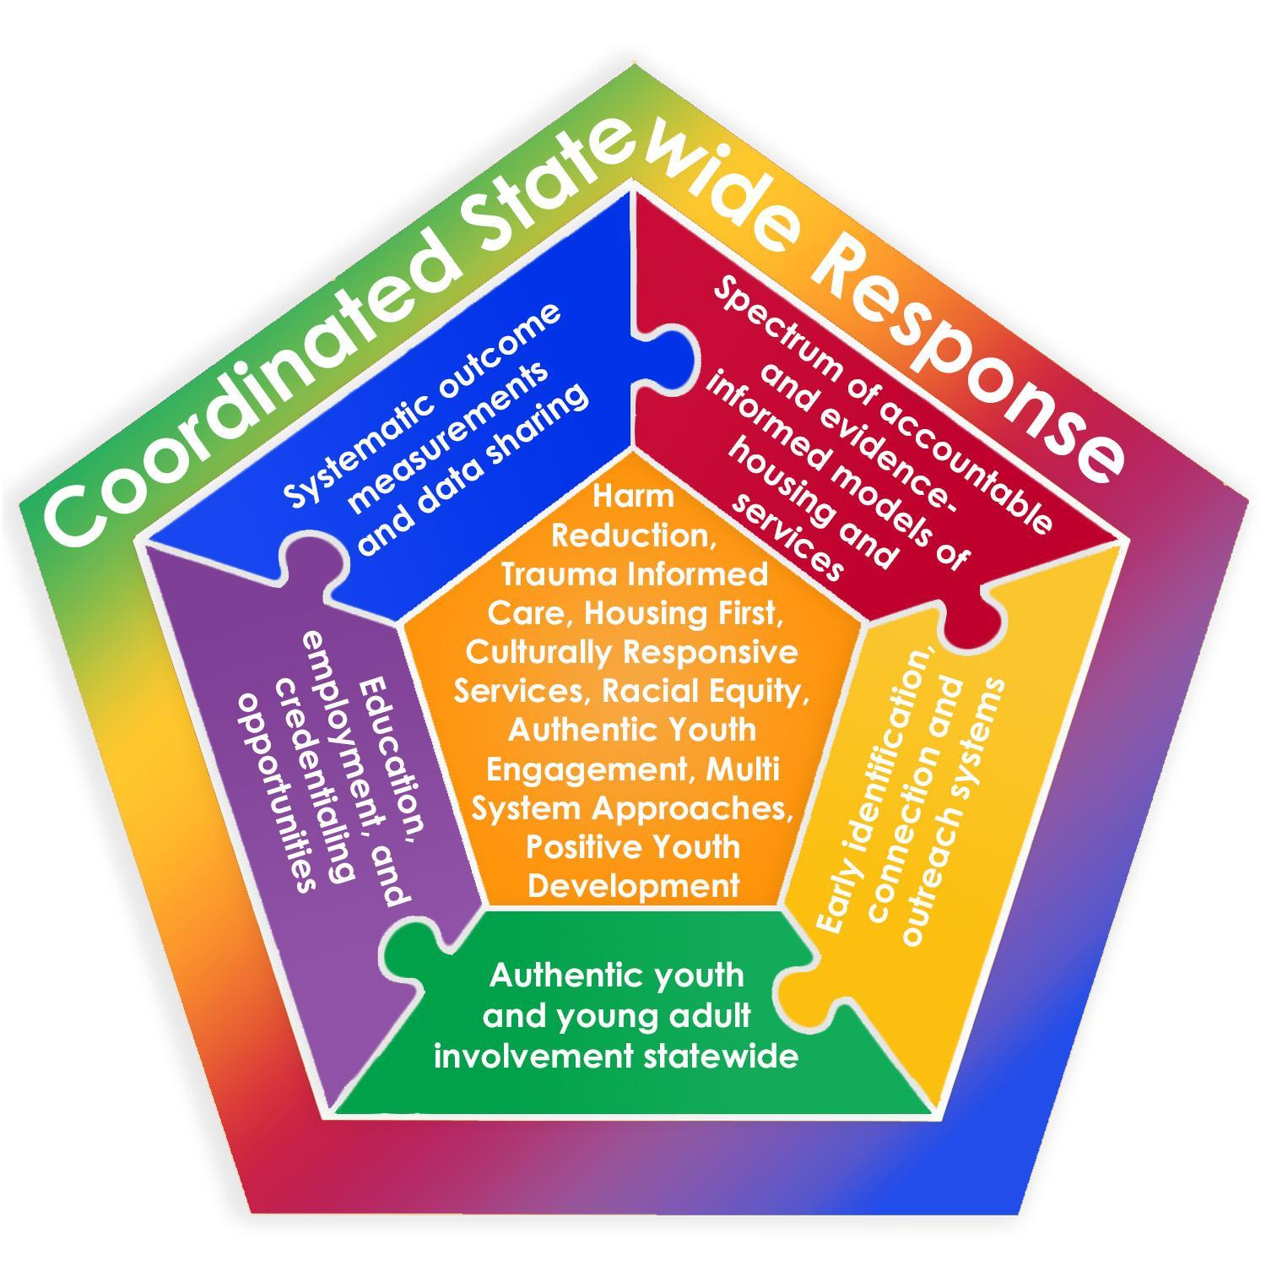.
The following is an overview of proposed recommendations and desired outcomes related to each recommendation.

Recommendation A: Implement a Coordinated Statewide response to Youth Homelessness
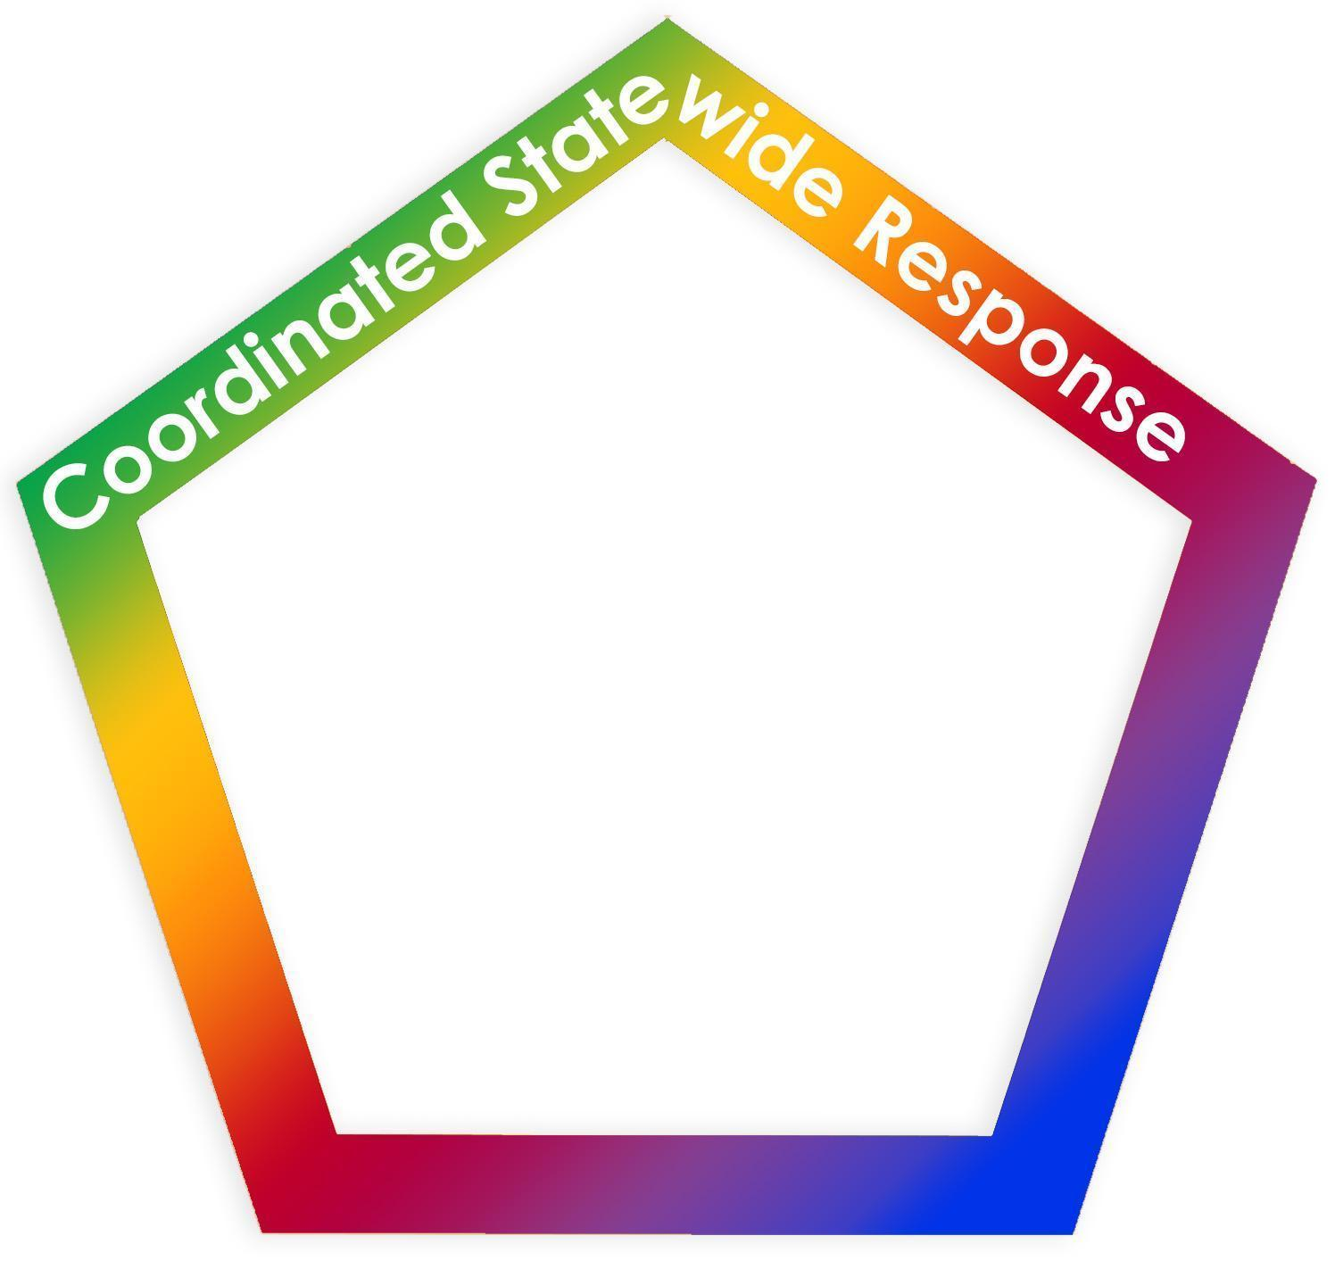
Outcome 1: Enhanced state-level operational capacity to prevent and end youth homelessness
Outcome 2: Enhanced regional capacity to prevent and end youth
homelessness
Outcome 3: Enhanced connection among direct-service programs throughout the state

This recommendation is seen as the container and facilitator for all other recommendations in the Plan.

Data gathered from stakeholder interviews, provider surveys, focus groups, and roundtable discussions all highlighted a salient and primary need for Massachusetts to address and end youth and young adult homelessness: the need for a coordinated statewide response. This included the need for dedicated staff to lead, manage, and coordinate a state-level response; a coordinated effort to harness the various champions, leaders, and advocates into a collective voice and direction; a structure to support the development of regional and local plans; and a network of connected and supported programs and services

“I believe that we can all learn from each other. Without the wrap-around and support of all of our communities, we are failing at working towards the same goal together.” -provider survey

The ability to plan and implement a statewide coordinated system for YYA experiencing housing instability depends on having dedicated staff to lead project activities and engage state and regional stakeholders in continuing plan development and implementation. The primary recommendation is that a full-time Executive Director (ED) of the Unaccompanied Homeless Youth Commission position is established and housed within EOHHS, reporting to the Executive Director of the Interagency Council on Housing and Homelessness. EOHHS has funds earmarked for the Commission, and this position could be initially supported by some of those funds. With focused leadership, the Commission could further progress on its mandate to provide comprehensive and effective responses to the unique needs of this population through facilitation of information-sharing including across state agencies.

With an Executive Director position in place, the Commission would be capable of enhancing regional capacity to prevent and end youth homelessness. Training and technical assistance could be provided to Continua of Care (CoC) and/or regional housing networks to conduct needs assessments and develop local plans to end youth homelessness. Additionally, ongoing coordination, training, and information sharing could also be offered to local providers.

Recommendation B: Expand the current spectrum of accountable and evidence- informed models of housing and services
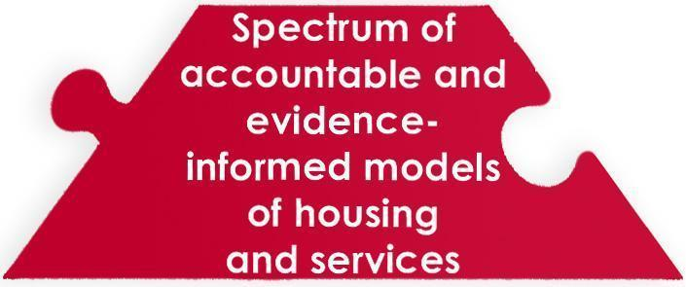
Outcome 1: A flexible, regional response to YYA homelessness is developed, including shelter, triage, assessment and housing services and supports.
Outcome 2: Housing and service needs for subpopulations of unaccompanied homeless youth are addressed, and partnerships with state agencies are developed to ensure informed and fully utilized statewide services
Outcome 3) Housing opportunities available to YYA are established and expanded
Outcome 4) Stable funds are made available for supportive services
Outcome 5: Number of bed nights for young adults in adult shelters statewide are reduced through diversion
Outcome 6: Programs and services have access to flexible funding to meet needs of individual YYA

There is currently a statewide shortage of affordable housing, and homelessness cannot be ended if there are not enough affordable housing units in which people can live. Interviews with state agencies, focus groups, and the provider survey all emphasized both the widespread lack of affordable housing, as well as the vast regional differences in availability of housing models, units, and youth-specific support services. Both youth and providers expressed concerns regarding the lack of services available for youth experiencing homelessness in many areas of the state. Conversely, Boston area providers, who currently have a range of youth-services including drop-in-centers and YYA shelters, reported having to send young adults to outside of the city and outside of their support range in order to obtain affordable housing. Without access to housing, young adults are staying in unsafe accommodation or accessing the adult emergency shelter system, which may place them at significant risk for violence, abuse and exploitation.

“There is no shelter [here] for youth. There is no assisted housing, subsidized or affordable housing, for kids trying to stay in high school or go to college. I can get them to food pantries, sign them up for health insurance and SNAP but I can't find them a roof so they can continue to better themselves and transition into self-sufficiency. They need a safe place to keep their belongings; they need to not spend their day hustling for a place to sleep, so they can focus on being their best selves and getting the counseling, the medical services, and the education they need to be successful.” – provider survey
*
“Nothing is ever readily available. Housing or help. There is help out there, don’t get me wrong. But most of the time there tends to be a wait list. You get called back after three months, and by that time, its just too late. – YYA, 19, Framingham

In order to advocate for adequate expansion of housing, the existing number of units and models of housing for YYA must be first established. Once numbers are better determined, there can be identification and evaluation of current and potential funding for housing, including permanent supportive housing, and services across the state. Temporary, transitional and permanent housing across the state must also include a supply and range of options that do not require sobriety, have minimum income requirements, or require absence of a criminal record. The presence or creation of low-threshold supports and services, such as drop in centers, in every region was also identified as a key strategy to improving YYA stability. Then, by connecting YYA experiencing homelessness to appropriate housing and services, they will have a stable foundation from which they can address their other areas of need such as education, employment, and substance use.

There are service-delivery needs specific to each of the vulnerable subpopulations over-represented among YYA experiencing homelessness. These subpopulations include LGBTQ youth; pregnant and parenting youth; youth under 18; victims of sexual trafficking and exploitation; youth with multiple systems involvement; YYA with mental health and substance use disorders; undocumented and immigrant youth; college students experiencing hunger and homelessness; and YYA who are experiencing intimate partner violence. Part of this recommendation is for the Commission to create work groups, co-chaired by the new ED of the Commission and leading experts in these areas, to identify best practices and models for screening, assessment, and intervention with these subpopulations. Alternatively, the ED can join existing working groups for the subpopulation that are not focused on YYA homelessness in order to ensure the needs of young adults experiencing homelessness from this subpopulation are highlighted. Each working group will be also tasked with developing appropriate materials to train state agencies and service providers on the integration of needs, best practices, and cultural competencies. It is also important to note that many YYA have characteristics associated with multiple subpopulations, (i.e. an LGBTQ YYA with a substance use disorder who is experiencing domestic violence). A key role for the ED and the working groups will be to support a holistic approach to service delivery for YYA with multiple challenges.

It is also imperative to divert young adults from adult emergency shelter systems as much as possible. The U.S. Interagency Council on Homelessness (USICH) has recommended a set of community-level criteria for ending youth homelessness that includes “...prevention and diversion strategies whenever possible, and otherwise provides immediate access to low-barrier crisis housing and services to any youth who needs and wants it.” It is recommended that a statewide assessment is conducted to understand how current outreach, shelter, and other YYA access points are incorporating diversion practices. CoCs may then be trained in family and community engagement for the purpose of diversion to complement primary prevention efforts.

Once housed, many YYA will have a continued need for support services, and these services will need stable funding mechanisms attached. The Massachusetts Department of Public Health (DPH) Bureau of Substance Addiction Services (BSAS) has as a specialized service for supportive case management for YYA, and is currently working with Medicaid (MassHealth) to explore funding for supportive case management services that include specialized staffing patterns for YYA. It is recommended that the Unaccompanied Homeless Youth Commission partner with BSAS, MassHealth, and other funding mechanisms to inform appropriate reimbursable tenancy supports for young adults.

Additionally, providers from across the Commonwealth articulated the need for flexible funding pools in order to access direct financial assistance to meet the variety of needs of YYA experiencing housing instability. One provider referred to these flexible funds as “barrier buster money” -- funding that could address and overcome unique issues such as childcare arrears, funding for transportation, or paying a small legal fee. Such funds are a needed resource for overcoming unique barriers to stability for many YYA.

Recommendation C: Enhance early identification, connection, and outreach systems to improve young people’s connection to existing resources
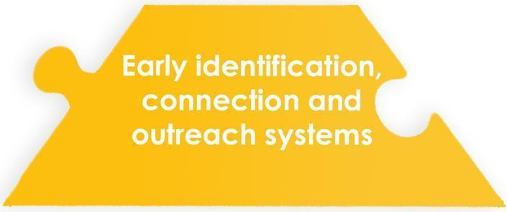
Outcome 1: Improved ability to identify YYA at risk of housing instability and homelessness within non-homeless service programs, including youth transitioning out of state systems of care.
Outcome 2: Reduced amount of time between a young adult experiencing housing instability and connecting with services and supports.

As previously mentioned, USICH recommends that YYA be prevented or diverted from experiencing homelessness whenever possible, and they suggest this be accomplished through “substantial partnership” with schools, the child welfare and justice systems, employment, physical and behavioral health, and other youth-serving programs. However, many of these entities do not currently have an adequate understanding or ability to recognize housing instability in YYA, and even if they do, they often do not know where to refer a young person to who needs support services. Nearly two-thirds of surveyed providers reported a need for a comprehensive, “consistently updated” resource guide, stating that they either did not currently have one, or it was not YYA specific, and therefore they often did not know the appropriate options for their clients.

Likewise, young adults also expressed feeling alone when facing housing instability. Throughout the focus groups numerous YYA experiencing homelessness expressed a feeling of isolation, commenting that they did not know anyone else experiencing similar situations or resources to support them. When asked about the moment they realized they were “Capital H-Homeless,” many said it was the moment they had nowhere to go and no one to turn to. This period of isolation was not only stressful, but presented a window for violence, victimization, and exploitation. Many focus group participants expressed wishing they had known about available resources earlier, as an earlier connection could have prevented some negative outcomes.

“Wish I knew what the resources were – what places provided what help. I would have [gone to get services] at the moment I got kicked out”-YYA, 20, Greenfield
*
“As long as you have abusive and neglectful families, you will always have homeless youth. Your job [as a service provider] is to get us off the streets as quickly as possible - because the longer we’re on the streets, the more bad things happen to us, and the more bad things happen to us, the harder it is to get off the streets.” -YYA, 19, Boston
*
“You don't hear about this in school so we don't know about ways to get help. Something serious had to happen to me for me to get help, instead of knowing beforehand so you can be prepared. It would be better if you knew what to do before something happens instead of just waiting until things fall apart to call someone. – YYA, 20, Orleans

In order to ensure that YYA experiencing homelessness are quickly identified and appropriately connected with services and supports, a number of state-level actions can be undertaken. By improving the ability for non-homeless serving agencies, including schools and state systems of care, to identify youth at risk for homelessness, prevention and intervention points can be accessed earlier. Creating and integrating an identification tool and connection protocol into existing risk assessments and intake processes can accomplish this. The identification tool should be based off of other research-based identification tools, such as the Youth Assessment and Prioritization Tool (YAP), used in Canada to assess YYA’s risk of homelessness and identify needed supports.

Additionally, the Transition Planning work group of EOHHS is in the process of finalizing a report outlining best practices and recommendations for individuals who are transitioning to or from an EOHHS agency and/or related service system, including YYA transitioning out of state care. Integrating that work into youth homelessness prevention will be crucial to ensuring early identification and connection.

A secondary action to minimize the time between the start of housing instability and connection to supports and services would be to create an integrated, up-to-date, statewide, referral system and/or online resource guide. Youth in focus groups reported that they had trouble finding resources, often simply Googling some combination of “homeless” “teen” and “help”. Often they reported finding only information about adult homeless shelters or food pantries, neither of which are appropriately equipped to meet the prevention, intervention, or developmental needs of young adults. Additionally, some providers reported not being able to adequately connect with potential clients to inform them of services offered. A continuously updated on-line resource guide might easily fill this gap. The Youth Service Network of Minnesota developed a mobile-optimized web application designed to easily connect youth who are “homeless, in crisis, or at risk of either,” to the services they need. The app includes daily updates of shelter bed availability sorted by distance from current location, ways to connect with outreach workers, drop-in centers, food resources, and medical and crisis line resources. It aims to be a comprehensive resource for youth in MN facing housing instability and homelessness. Having a similar resource created in Massachusetts would create a platform for a statewide information campaign to be launched, assuring youth that they are not alone in their struggles and encouraging them to reach out to service providers as early as possible.

Recommendation D: Improve education, employment, and credentialing opportunities in order to support young people’s access to long term, sustainable employment and income
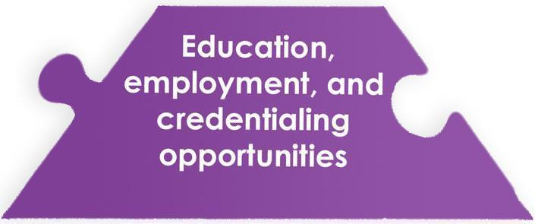
Outcome 1: Improved outcomes, including graduation rates, for high school students facing housing instability
Outcome 2: A comprehensive approach to mitigating housing challenges and economic insecurity of current and prospective college students.
Outcome 3: Improved opportunities for YYA experiencing or at risk of homelessness to further their employment and training opportunities

Education and employment are core outcomes within the USICH Framework to End Youth Homelessness, and their importance was consistently affirmed in focus groups, interviews, and the provider survey. However, there are also multiple barriers that YYA experiencing homelessness must address in order to advance their education and employment opportunities: who has funding to pay for educational advancement? How can a young person obtain a job that pays more than minimum wage? Where do college students experiencing homelessness go when dorms are closed during vacations and summers? Many of these concerns stem from a lack of coordination between education/employment providers and the programs that specifically serve YYA experiencing homelessness.

Education: Connections should be facilitated among state-level educational support systems and regional service providers so that there is expanded access to resources. Making these connections at both high school and college levels will ensure a continuum of supports for YYA, thus improving outcomes for students facing housing instability, such as high school and college graduation rates. There should be continued partnership between the UHY Commission, the Department of Elementary and Secondary Education (DESE), the Department of Higher Education (DHE), and WIOA-youth to aid students who are unaccompanied and experiencing housing instability. Massachusetts recently completed a statewide “Hunger and Homelessness” survey of college students, and the data from this survey can offer insight to what the areas of highest need are. Additionally, while the majority of public college campuses in Massachusetts already have a Single Point of Contact (SPOC), it is recommended to increase this number at all college and university campuses, including at 100% of public college campuses.

Employment:
“Employment is crucial, because if someone can pay rent, they don’t have to sit around and hope and wait for a voucher or affordable housing unit.” -provider survey
*
“Getting a job is really hard without experience. But someone just has to take a chance on you. How are you going to get experience, if you need experience to get experience?”
– YYA, 23, Springfield

Massachusetts has an opportunity to increase its workforce potential by connecting YYA experiencing homelessness to the labor market. The new Executive Director of the UHY Commission will facilitate connections between the UHY Commission members and WIOA-youth and their 16 regional Workforce Boards. Additional opportunities for connecting YYA into the workforce may arise from an identification and expansion of current models of public-private partnership (like the Private Industry Council in Boston) as well as social enterprise opportunities.

MA Program Spotlight: Social Enterprise- The Haven Project, Lynn, MA.
Opened in 2012, the Haven Project serves unaccompanied homeless young adults ages 17-24 from communities north of Boston. They offer a drop-in center, on-site preparation for the High School Equivalency Test (HiSET), a social enterprise, host homes and a transitional apartment. In January of 2016, they began an innovative job-training program by opening a coffee shop, “Land of A Thousand Hills Café.” Half of the cafe staff are Haven Project clients who receive an income and individualized job coaching to learn the skills to be successful in further employment opportunities. In early 2017, 20 youth were hired in the café and these jobs provided opportunities to gain experience, references and constructive feedback in a supportive environment. Then, in the summer of 2017, in order to create more low barrier employment opportunities, the program developed a line of products to positively engage their highest risk clients in paid skill development. The job- program also develops partnerships with community businesses to ensure successful transition to full time employment and secondary education.

Recommendation E: Create systematic outcome measurement systems and data sharing opportunities
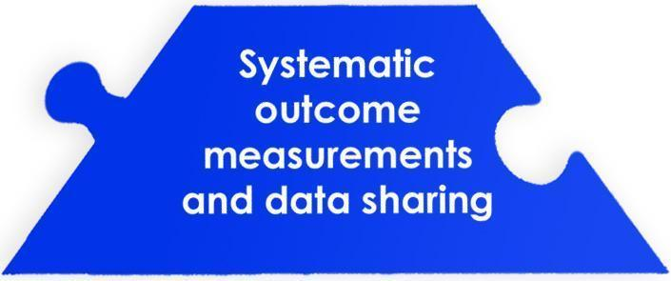
Outcome 1: Consistent eligibility criteria for all services to unaccompanied homeless youth
Outcome 2: Consistent statewide definition of unaccompanied youth across state funded services
Outcome 3: Statewide dashboard / monitoring platform for population size and characteristics
Outcome 4: Analysis and use of data in policy making,
funding decisions, resource allocation and programming
Outcome 5: Inter-/multi-agency data matching agreements to identify agency involvement of youth

While it is anecdotally known that unaccompanied homeless youth are served by multiple state agencies, there is nevertheless a limited understanding of who they are, how many there are, and how they are utilizing these services. In every state agency interview the question was asked, “How does your agency define ‘homelessness’ for a youth and/or young adult?” Many respondents had no answer at all, stating that their agency did not have capacity for adopting a standard definition, and if there were young people who were experiencing homelessness while being served by these agencies, this was often not well documented. Without a uniform definition, data collection becomes unreliable, and without reliable data it is not possible to define the scope and scale of the issue or track progress.

“It’s hard to form true integrated service delivery systems

if you don’t have good data access to scope out the problem.” -Stakeholder

In order to prevent and end youth homelessness in Massachusetts, one must first be able to define and measure the problem. Recently, Massachusetts has made some significant progress collecting data through the annual statewide Youth Count as well as the Hunger and Homelessness Survey administered by the Department of Higher Education on public campuses. However, an even more intentional and coordinated strategy is needed for obtaining and compiling data across state agencies in order to fully advance the understanding of the issue and refine the plan to end youth homelessness in the Commonwealth.

This plan recommends adoption of the Commission’s definition of unaccompanied youth across state funded services, recognizing the importance of also needing to catalogue and understand existing external (i.e. non state) definitions of “homeless youth and young adults” by other funding source and services provided. The recommendation also includes creating a statewide data dashboard to have an easy-to-understand visual representation of data and outcomes monitoring. Partnering with EOHHS’s statewide HMIS “data warehouse” as well as DPH’s Chapter 55 homelessness-prevention data will be key action-steps towards obtaining data to achieve this outcome.
Recommendation F: Create a structure to support authentic youth involvement statewide
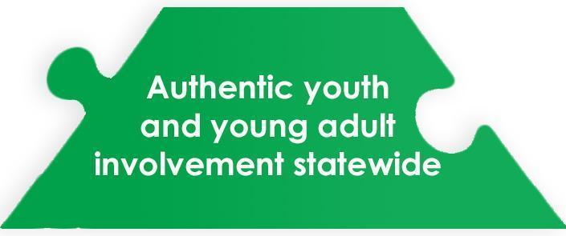
Outcome 1: Definition of authentic youth engagement and contextual guidance provided to state agencies, communities, and partners
Outcome 2: Improved statewide capacity for youth engagement

Another theme that consistently came up in focus groups, provider surveys, and stakeholder interviews was the need for more leadership and leadership development of young adults with lived experiences of homelessness. While providers and interviewees expressed valuing youth engagement and desiring more opportunities to utilize YYA’s dynamic lived experience in the programs and at the state level, they felt that they needed adequate support or resources to make it a reality. Focus group participants throughout the state also voiced a desire for more engagement, more opportunities to interact with peers, and more opportunities to use their voices and experiences to influence perception, programming, policy, and practice.

“This focus group helps me to see a hope that this can get better.
I only hope we can continue to do this work in the future” YYA, 22, Greenfield
*
“The Youth Advisory Board has shown me that I have a voice,
and that voice is strong and fully capable to make a change.” - YYA, 19, Boston
*
“We can’t expand to special populations such as LGBTQ, trafficked youth, etc,
until their voice is incorporated into the planning” -stakeholder

Encouraging local Youth Action Boards (YABs) are one way to cultivate leadership of youth and young adults. YAB’s integrate youth into the planning and implementation decision making on policies and planning that directly affects them. The U.S Housing and Urban Development’s (HUD) Guide for Engaging Youth in Decision Making and Planning describes YABs as a best practice, saying “They provide important development opportunities for the young people who participate, serve as a sounding board for stakeholder ideas, and generate invaluable new ideas that can only come with first hand perspective. YABs should be an ongoing, YYA led community initiative rather than just a response to a single application or project need.” A number of state-level programs as well as cities across Massachusetts currently have active YABs that could be used to develop material and provide trainings, further cultivating the YYA leadership base and providing more opportunities for skill development and income generation. Once young adult leaders are engaged at the local level, the ultimate goal of a unified and structured statewide network of YABs will be attainable.

Creating statewide guidance policy on youth engagement that includes best practices in partnership and decision-making capacity is a vital component in developing structures for authentic youth involvement. It is essential that any youth leadership entity have clear and defined standards to inform and ensure authentic community and provider partnership, and an understanding of practices to best support YYA in taking on authentic leadership roles. The ultimate goal in developing statewide structure for youth leadership is to have YYA involvement in every agency and service component, identify reliable funding streams to create tools, trainings and resources to develop, support and sustain local YYA leadership and Youth Action Boards.

Action Plan
The following table expands the recommendation into a series of action steps. Each outcome was derived from identified /needs, and is accompanied with strategies to address the need alongside designated ownership. It is the intention of this table to provide a clear strategic framework with long and short-term strategies to implement at the state level.

Recommendation A: Implement a coordinated statewide response to youth homelessness
Outcome | Strategy | Stakeholders |  | Timeframe |  |  |  |  | Possible with current funding resources
 |  |  |  | Short | Med | Long | On-going |  | Yes |  | No
1) Enhanced state-level operational capacity to prevent and end youth homelessness | Strategy A: Identify and hire an Executive Director for the UHY commission | UHY Commission lead with ICHH, EOHHS, State Agencies
 | Strategy B: Compile State Agencies’ mandates and initiatives connected to YYA Homelessness and regularly present these at the Unaccompanied Homeless Youth Commission meetings. | UHY Commission, ED of UHY Commission
2) Enhanced regional capacity to prevent and end youth homelessness | Strategy A: Assess regional capacities to prevent and end YYA homelessness | ED of UHY Commission, COCs, Youth Action Boards
 | Strategy B: Provide training and TA for conducting regional need assessments | ED of UHY Commission, COCs, Youth Action Boards
 | Strategy C: Provide training and TA for developing regional plans to end YYA homelessness. | ED of UHY Commission, consultants, foundations
Outcome | Strategy | Stakeholders |  | Timeframe |  |  |  |  | Possible with current funding resources
 |  |  |  | Short | Med | Long | On-going |  | Yes |  | No
3) Enhanced connection among direct-service programs throughout the state | Strategy A: Convene daylong annual statewide retreat for service providers to share evidence-based best practices, challenges, resources, and data-collection efforts. | ED of UHY Commission, UHY Commission Members, Local Providers
 | Strategy B: Create online platform for Learning Community and Resource Sharing | ED of UHY Commission,  External Consultant  UHY Commission members, Local Providers
Recommendation B: Expand the current spectrum of accountable and evidence-informed models of housing and services
Outcome | Strategy |  | Stakeholders | Timeframe |  |  |  | Possible with current funding resources
 |  |  |  | Short | Med | Long | On-going | Yes |  |  | No
1) Development of a flexible, regional response to YYA homelessness including shelter, triage, assessment and housing services and supports. | Strategy A: Convene CoCs to establish the numbers of existing and needed units and models of housing across the state |  | Mayor’s forums, CoCs,  local providers, DHCD, HUD local office, youth action board, Mass Coalition for the Homeless, MHSA, ICHH
Outcome | Strategy |  | Stakeholders | Timeframe |  |  |  | Possible with current funding resources
 |  |  |  | Short | Med | Long | On-going | Yes |  |  | No
 | Strategy B: Convene CoCs to identify the numbers and types of existing support services across the state |  | Mayor’s forums, CoCs,  local providers, DHCD, HUD local office, youth action board, Mass Coalition for the Homeless, MHSA, ICHH
 | Strategy C: Identify and evaluate current and potential funding for housing, including supportive housing, and services across the state |  | Mayor’s forums, CoCs local providers, DHCD, HUD local office, youth action board, Mass Coalition for the Homeless, MHSA, ICHH
 | Strategy D: Identify and/or create one low-barrier resource center (drop-in center) for YYA in every region (as stand-alone centers or integrated into existing programs or centers) |  | Mayor’s forums, CoCs, local providers, DHCD, HUD local office, YABs, Mass Coalition for the Homeless, MHSA, ICHH, FRC, HCEC, DPH
2) Housing and service needs for special populations of unaccompanied homeless youth are understood, and partnerships are developed with state agencies to ensure adequate, informed, and fully utilized statewide services | Strategy A: Create working groups for each special population identified in the report comprised of advocates, people with lived experience, providers, UHY ED, and state agencies that provide services to the sub-populations. Alternatively, integrate UHY ED and YYA with lived experience of homelessness into existing work groups. |  | UHY ED, Service Providers DPH/BSAS, CoCs  For each special-population, stakeholders include: advocates, people with lived experience, providers, UHY ED, and state agencies that provide services to the special populations
Outcome | Strategy |  | Stakeholders | Timeframe |  |  |  | Possible with current funding resources
 |  |  |  | Short | Med | Long | On-going | Yes |  |  | No
 | Strategy B: Each working group assesses current resources and utilization, service needs, barriers, and relevant policy. |  | Same as above
 | Strategy C: Each working group creates appropriate training plan to train state agencies and service providers on needs, best practices, and cultural competencies. |  | Same as above
 | Strategy D: Each working group implements training plan |  | Same as above
3) Number of housing opportunities available to YYA are established and expanded | Strategy A: Work with DHCD to prioritize YYA housing rental rounds, supporting a range of housing options, including low-threshold units |  | DHCD, Mass Coalition for the Homeless
 | Strategy B: Explore models of how housing/rent collection may be made flexible for this population (while still fostering accountability and responsibility), including exploration of Rapid Re-Housing models for YYA |  | DHCD, Mass Coalition for the Homeless
 | Strategy C: Increase funding for rental subsidies |  | DHCD
Outcome | Strategy |  | Stakeholders | Timeframe |  |  |  | Possible with current funding resources
 |  |  |  | Short | Med | Long | On-going | Yes |  |  | No
4) Increased stable funds available for supportive services | Strategy A: Partner with BSAS and MassHealth to explore appropriate Medicaid-reimbursable tenancy supports (CSPECH-like) for YYA |  | MassHealth, DPH/BSAS, ICHH, ED of UHY Commission, MHSA
 | Strategy B: Inventory state and federal funding streams for possible use to support programs and services and develop additional resources/funding streams, as needed, based on above assessment. |  | ED of UHY Commission, MHSA
5) Reduced number of bed nights for young adults in adult shelters statewide through diversion | Strategy A: Assess how current outreach, shelter, and other YYA access points are incorporating diversion practices |  | ED of UHY Commission, Shelters, COCs
 | Strategy B: Train providers in family and community engagement for the purpose of diversion to complement primary prevention efforts |  | Consultant and UHY Commission and providers
 | Strategy C: Develop and distribute best-practice guidelines and recommendations for serving YYA in adult shelters based on recommendations from youth, providers, and practices in other states |  | ED of UHY Commission, YABs, Shelters
 | Strategy D: Ensure all adult-shelters know local and regional youth-specific resources |  | EOHHS, ICHH, UHY Commission
Outcome | Strategy |  | Stakeholders | Timeframe |  |  |  | Possible with current funding resources
 |  |  |  | Short | Med | Long | On-going | Yes |  | No
Outcome 6: Programs and services have access to flexible funding to meet needs of individual YYA | Strategy A: Support continued dedicated state funding with program level flexibility |  | Administration, Executive branch of the Legislature
 | Strategy B: Utilize dedicated state funding to leverage additional private and foundation resources |  | ED of UHY Commission, Foundations, COCs
Recommendation C: Enhance early identification, connection and outreach systems to improve young people’s
connection to existing resources
Outcome | Strategy |  | Stakeholders | Timeframe |  |  |  |  | Possible with current funding resources
 |  |  |  | Short | Med | Long | On-going |  | Yes |  | No
1) Improved ability to identify YYA at risk of housing instability and homelessness within non-homeless service programs, including youth transitioning out of state systems of care. | Strategy A: Create a “Protocol for identification” and related training material that can be used statewide and distributed by State agencies, CoCs to providers and other entities (courts, hospitals, schools, etc.) to identify youth at risk for homelessness |  | ED of UHY Commission, DPH/ Chapter 55 data, State agencies, local providers, youth advisory boards, DCF (including family resource centers), CoCs
 | Strategy B: Connect with the EOHHS Transitional Planning workgroup to identify and implement recommendations |  | ED of UHY Commission, Transition Planning Workgroup
Outcome | Strategy |  | Stakeholders | Timeframe |  |  |  |  | Possible with current funding resources
 |  |  |  | Short | Med | Long | On-going |  | Yes |  |  | No
2) Reduced amount of time between a young adult experiencing housing instability and connecting with services and supports. | Strategy A: develop an integrated, up-to-date, statewide, referral system and/or online resource guide that includes a map of statewide distribution of resources (can use MN as a template) |  | ED of UHY Commission External consultant, Programs
 | Strategy B: Create a statewide awareness campaign, that includes social media, to encourage YYA who are facing housing instability to reach out early to service providers, and ensure distribution of campaign in high schools and campuses |  | ED of UHY Commission, UHY Commission Members, CoCs, youth advisory board, Pro-Bono Advertising Agency
Recommendation D: Improve education, employment, and credentialing opportunities in order to
support young people’s access to long term, sustainable employment and income
Outcome | Strategy | Stakeholders |  | Timeframe |  |  |  |  | Possible with current funding resources
 |  |  |  | Short | Med | Long | On-going |  | Yes |  |  | No
1) Improved outcomes, including graduation rates, for high school students facing housing instability |  | WIOA-youth programs/ DCF EOLWFD, ED of UHY Commission (to coordinate service providers, including Youthbuild, Job Corps, ROCA, etc ), MRC
 | Strategy A: Facilitate connections between education and credentialing programs (such as DESE, WIOA-youth programs, BSAS-funded recovery high schools, etc) and direct-service providers to create new partnerships and expand access to resources
2) A comprehensive approach to mitigating housing challenges and economic insecurity of current and prospective college students. | Strategy A: Utilize the results of the 2017 statewide Hope Lab survey of college students to determine areas of highest need | Dept of HigherEd, ED of UHY Commission, MA public colleges and universities, DESE, UHY Commission
 | Strategy B. Create a Single Point of Contact (SPOC) at all college and university campuses, including at 100% of public college campuses
 |  | DHE
 | Strategy C- Facilitate relationships between Single Points of Contact (SPOCs) at local campuses and local YYA service providers focusing explicitly on unaccompanied youth | DHE, ED UHY, Providers, UHY Commission
Outcome | Strategy | Stakeholders |  | Timeframe |  |  |  |  | Possible with current funding resources
 |  |  |  | Short | Med | Long | On-going |  | Yes |  |  | No
3) Improved opportunities for YYA experiencing or at risk of homelessness to further their employment and training opportunities | Strategy A: Identify, focus, expand, and replicate models of public-private partnership (like the Private Industry Council in Boston) as well as social enterprise opportunities (such as More Than Words, The Haven Project). | Local Providers, Business associations, Local industry leaders, Mayors, ED of UHY Commission, Workforce Development Boards
 | Strategy B: Connect Unaccompanied Homeless Youth Commission with Workforce Development Boards to understand existing WIOA youth programs that offer work experiences and skills training for YYA. | ED of UHY Commission, UHY Commission members, WIOA-youth, Workforce Development Boards

Recommendation E: Create systematic outcome measurement systems and data sharing opportunities
Outcome | Strategy | Stakeholders | Timeframe |  |  |  | Possible with current funding resources
 |  |  | Short | Med | Long | On-going | Yes | No
1) Identification of eligibility criteria for all services to unaccompanied homeless youth | Strategy A: Catalogue existing external (i.e. non state) definitions of “homeless youth and young adults” by funding source and services provided | ED of UHY Commission, ICHH, UHY Commission
2) Alignment of statewide definition of unaccompanied youth across state funded services | Strategy A: Adopt common definition of “unaccompanied homeless youth” (including age ranges) across service delivery and housing systems | EOHHS, ICHH, UHY Commission
3) Creation of statewide dashboard / monitoring platform for population size and characteristics | Strategy A: Partner with Statewide CoC/HMIS data-warehouse team to explore how this data informs a coordinated statewide response to YYA homelessness | DHCD, ICHH/CoC/HMIS workgroup, ED of UHY Commission, youth action board, ID and connection working group
 | Strategy B: Engage with non HUD-funded providers to understand opportunities and overcome barriers to use of HMIS. | DHCD, EOHHS, ED of UHY Commission, CoC’s, provider

Outcome | Strategy | Stakeholders |  | Timeframe |  |  |  |  | Possible with current funding resources
 |  |  |  | Short |  | Med | Long | On-going | Yes |  | No
3) Creation of statewide dashboard / monitoring platform for population size and characteristics | Strategy C: Compare and align intake forms statewide to ensure standardized data collection | Local providers, ED of UHY Commission, ID/connection working group
 | Strategy D: Identify and collect data from a range of existing statewide data sources to improve baseline estimates of young adults experiencing and at risk of homelessness. | WIOA-youth programs, Mass LGBT Youth Commission, DPH/ Chapter 55, ID/Connection workgroup, DESE, Higher ED, COCs, Youth-serving programs, ED of UHY Commission, Data Warehouse
 | Strategy E: Develop a dashboard/ outcomes monitoring platform | outside tech TA, DPH, EOHHS
4) Development of inter/multi-agency data sharing agreements to identify agency involvement of youth | Strategy A: Refer to Draft Transition Planning document to identify barriers to sharing data across agencies and other DHS initiatives | ED UHY, EOHHS Master Data Management Initiative, Transition Planning Group
 | Strategy B: Create multi-agency data sharing agreements | ED UHY, EOHHS Master Data Management Initiative, Transition Planning Group, EHS IT, EHS Legal
Recommendation F: Create a structure to support authentic youth involvement statewide
Outcome | Strategy |  | Stakeholders |  | Timeframe |  |  |  |  | Possible with current funding
 |  |  |  |  | Short | Med | Long | On-going |  | Yes |  | No
1) Definition of authentic youth engagement and contextual guidance provided to state agencies, communities, and partners | Strategy A: Create statewide guidance policy on youth engagement that includes evidence based practices in partnership and decision making capacity |  | ED UHY Commission, UHY Commission, Boston Youth Action Board, YYA with lived experience across the state
2) Improved statewide capacity for youth engagement | Strategy A: Identify agency in each region to develop and host YAB. |  | ED UHY Commission, Consultants,
 | Strategy B: Create tools, trainings and resources to develop, support and sustain local YYA leadership and YABs |  | ED UHY Commission, Youth Consultants, Service providers, COCs
 | Strategy C: Identify funding streams to support YAB development at local and state levels. |  | ED UHY Commission, Private Foundations, COCs
 | Strategy D: Convene an annual meeting/ day-long retreat for YYA from across the state who have experienced housing instability and are interested in taking leadership in their communities. The retreat will include workshops on facilitation, advocacy, training, connection, and communication. |  | ED UHY Commission, YABs, Service Providers, COCs
 | Strategy E: Develop statewide network of local YABs with paid opportunities for work, training and skills-building |  | UHY ED, YABs, Service Providers, COCs, Foundations

PART II: BACKGROUND AND DATA INFORMING THE PLAN

1- DEFINITIONS

“When I was homeless, I stayed all over the place. At my job, in a junkyard car,
in the woods on a pile of leaves, and if I smelled good enough
I would go to a bar and hope someone would take me home” – YYA, 22, Boston
*
“When it really hit me [that I was homeless], was when I had to go pee. And I was outside.
And I had to go the other one and I couldn’t even do it because I had no napkins, no toilet paper,
no nothing. I just felt like not a real person, not a real human anymore.” -YYA, 19, Springfield

Policies, programming, and research about young people experiencing homelessness need consistent definitions for the terms “youth” and “homeless.” Leading experts define the population of homeless “youth” as being between the ages of 14-24 years. However, “adult” is often defined as being over the age of 18 for legal purposes and also in adult homeless statistics. This situation makes it difficult to develop coordinated policies or track outcomes and trends.

The definition that was agreed upon by the Massachusetts Unaccompanied Homeless Youth Commission in 2013 was that “Unaccompanied Homeless Youth” shall mean: a person 24 years of age or younger who is not in the physical custody of a parent or legal guardian, and who lacks a fixed, regular, and adequate nighttime residence. “Fixed” refers to a residence that is stationary, permanent and not subject to change. “Regular” means a dwelling at which a person resides on a regular basis (i.e. nightly). “Adequate” means that the dwelling provides safe shelter, meeting both physical and psychological needs of the youth. All three components of this definition- age, connection to a parent or guardian, and housing status- must be met in order for a person to be considered an unaccompanied homeless youth.

Q:“At what point did you realize you were “capital-H homeless”?
A: “It was the moment when I said to myself ‘Where the hell am I going to sleep tonight?”
-YYA, 22, Greenfield

It is important to note that in order to qualify for certain types of housing, a person must meet the definition of “literal homelessness” as defined by Housing and Urban Development (HUD). HUD defines homelessness as one of four categories,, and Category 1 Literal Homelessness is defined as: “Individuals and families who live in a place not meant for human habitation (including the streets or in their car), emergency shelter, transitional housing, and hotels paid for by a government or charitable organization.”

However, even with a definition of homelessness broader than HUD’s definition of “literal homelessness”, the definition used by the MA Unaccompanied Youth Commission is in line with federal efforts to end youth homelessness. US Interagency Council on Homelessness (USICH) and the U.S. Departments of Education, Health and Human Services, and Housing and Urban Development have all collaborated to develop a set of community- level criteria and benchmarks for ending youth homelessness that applies to all youth and young adults under the age of 25 who are unaccompanied by a parent, legal guardian, or caretaker and who meet any federal definition of homelessness. (See Appendix A for federal definitions of homelessness.)

In addition to a lack of secure housing, young people experiencing homelessness, like all young people, are undergoing significant social, physical, emotional and cognitive changes. The universal challenges of these developmental changes are magnified by the complex experiences of housing instability.

2- LEGISLATIVE HISTORY

Structure of the Commission: The Special Commission on Unaccompanied Homeless Youth (“the Commission”) was established through Outside Section 208 of the FY13 Budget, signed into law on July 8, 2012. The Commission was then reconstituted through Chapter 450 of the Acts of 2014. The purpose of the Commission is to study and make recommendations regarding services for unaccompanied youth and young adults experiencing homelessness in Massachusetts, to ultimately provide comprehensive and effective responses to the unique needs of this population. The focus of the commission’s work specifically includes assessing the barriers to serving unaccompanied homeless youth who are LGBTQ+ or under 18 years of age, an assessment of the impact of mandated reporting requirements on unaccompanied homeless youths’ access to services, improving the Commonwealth’s ability to identify, connect with, and reduce barriers for unaccompanied homeless youth. The Commission, chaired by the Executive Office of Health and Human Services, includes a wide membership, representing youth, state government, service providers, and advocates.

During the Fiscal Years 2013- 2017 state budget also included a line appropriation of $150,000 at the Executive Office of Health and Human Services (EOHHS) to continue the State’s commitment to better understand the scope of homelessness among unaccompanied youth. This language was removed from the FY18 budget, but EOHHS has expressed a commitment to continued support.

Statewide Youth Count: In 2014, Massachusetts conducted the first statewide count of young adults experiencing homelessness in the nation. The Massachusetts Youth Count (“Count”), under the oversight of the Special Commission on Unaccompanied Homeless Youth, has taken place annually since 2014, and is coordinated through the Continuums of Care(COCs). The Commission is responsible for reporting on its progress annually to the Governor’s Office, the Legislature, and the Office of the Child Advocate. In May 2017, the Commission conducted the fourth annual Count with participation from all 16 CoCs. The 2017 Count surveyed 2,711 youth and young adults, 501 of which met the Commission’s definition for homelessness, and 314 who met the HUD definition of homelessness. (See Appendix E for sample questionnaire and findings from the 2017 youth count.)

Housing and Support Services for Unaccompanied Homeless Youth: This legislation, passed by the Legislature in December 2014 and signed into law in January 2015, was created to increase housing opportunities and expand support services for youth and young adults ages 24 and younger who are experiencing homelessness outside the custody or care of a parent or guardian. For Fiscal Year 2016 (FY16), the Legislature allocated $2 million to implement the law. Due to the time required to complete a procurement process and establish a statewide network of consortia, $1 million was distributed in FY16 and the remaining $1 million was made available to support the consortia in FY17. An additional $1 million was included in the FY17 budget for a total investment of $3 million for FY16 and FY17.

The funding went to eight youth services providers that contracted with eight regional consortia (established under a different line item) spanning the Commonwealth (see map, Figure 1). Each consortium/youth provider had the necessary flexibility to develop and curate an individualized regional response that suited the specific needs of the young adult populations central to the design of services and interventions. All of the consortia/youth providers provided case management, supportive services and outreach, coordinated assessments, and flexible financial assistance to meet unique financial barriers to stability, such as utility arrears, move-in costs, child-care fees, and transportation needs, rental assistance and subsidies. The consortia also focused on collaboration and network development, working across systems and silos to create collaborative relationships and networks that included the Department of Elementary and Secondary Education (DESE), local high schools and alternative education programs, State Police High Risk Victims Unit, institutes of higher education including community colleges, housing authorities, Department of Transitional Assistance (DTA), Veterans’ organizations, Department of Children and Families (DCF), immigration support organizations, health centers/substance use treatment programs and Social service providers.

The funding for these projects was then dramatically reduced in FY18 to $675,000, and it is currently unclear what limited extent of services this funding level can support.
Figure 1. Map of Regional Consortia
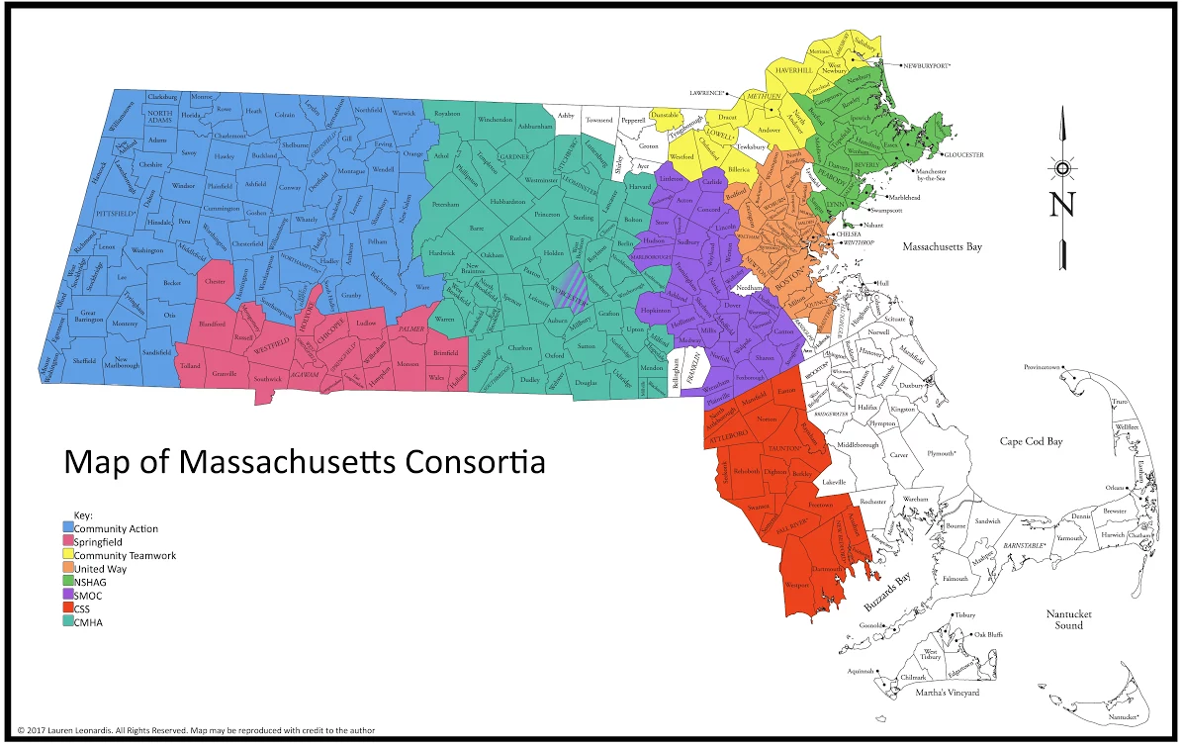

3- SCOPE AND PROCESS OF CREATING PLAN

This plan represents a strategic approach to prevent and end youth homelessness in the Commonwealth of Massachusetts. Statistics and best practices, alongside portraits of special populations, offer a lens to view current needs and strengths in the Commonwealth, then recommendations for meeting those needs are offered. The recommendations and the accompanying action plan serve as a roadmap for ending youth homelessness for the Executive Branch, the Legislature, and also for regional networks/Continua of Care (CoC) who are encouraged to develop their own regional plans to end youth homelessness.

This report was developed between February and December 2017, via a team of consultants with expertise in homelessness and housing policy, qualitative research, direct service, and also with lived experience of young adult homelessness. The Executive Director of the MA Interagency Council on Housing and Homelessness (ICHH) provided direct oversight to the team in conjunction with the MA Commission on Unaccompanied Homeless Youth. The consultants interviewed stakeholders from state agencies, conducted focus groups with young adults who were experiencing homelessness, surveyed homeless service providers, and held roundtable dialogues with representatives from the EOHHS-funded Youth Demonstration Projects, service providers, CoC leads and advocates.

Stakeholder interviews: Interviews were conducted between May and August 2017 with Commissioners and content-experts across State-level Departments and Offices:
- The Interagency Council on Housing and Homelessness (ICHH)
- Executive Office Health and Human Services (EOHHS), Office of Children Youth and Families
- Executive Office of Labor and Workforce Development (EOLWFD)
          - including follow-up with WIOA-Youth
- Department of Public Health (DPH), including additional follow-up with
          - Bureau of Substance Addiction Services (BSAS)
          - Bureau of Community Health and Prevention (BCHAP)
- Department of Housing and Community Development (DHCD)
- Department of Mental Health (DMH)
- Department of Children and Families (DCF)
- Department of Youth Services (DYS)
- Department of Elementary and Secondary Education (DESE)
- Department of Higher Education (DHEd)
- Department of Transitional Assistance (DTA)
- Department of Disability Services (DDS)
- MassHealth/Medicaid

Additionally, interviews were conducted with:
- Massachusetts LGBT Youth Commission (MLGBTYC)
- Massachusetts Coalition for the Homeless (MCH)
- Local and National Advocate and Youth Engagement expert
- Massachusetts Housing and Shelter Alliance (MHSA)

The interviews asked a series of questions in the following categories: 1) Definitions 2) Measurement systems and data 3) Communication and collaboration 4) Organizational support and 5) Direct support and engagement of youth and young adults. Each interview was approximately 75 minutes in length, and followed an interview guide that offered consistency to the content given. (See Appendix B for stakeholder interview guide). When consent was given, interviews were recorded and then transcribed. All transcriptions and notes were kept confidential by the consultants. Notes were then coded and analyzed for themes, with special attention paid to identified gaps and opportunities.

Focus Groups:

“This focus group helps me to see a hope that this can get better.
I only hope we can continue to do this work in the future” YYA, 22, Greenfield

With the support of the Liberty Mutual Foundation, nine focus groups were conducted across the Commonwealth with 55 young adults who had experienced homelessness and housing instability. One of these groups was conducted at an LGBTQ-specific agency, to ensure capturing experiences of this subpopulation. Groups were organized with local service providers and facilitated by trained YYA with lived experience of homelessness. The protocol was developed to understand participants’ direct and varied experiences of housing instability, identify barriers to services and opportunities for intervention, and collect recommendations for service improvement. Groups were recorded and transcribed, and then analyzed for themes and regional differences. Focus groups were conducted in: Boston (2), Springfield, Framingham, New Bedford, Orleans, Lynn, Springfield, and Lowell. (Focus Group guide can be found in Appendix C)

Provider Survey: Direct service staff have unique perspectives on the challenges faced by both individuals and organizations and contributed another layer of depth to the understanding of the work needed in the Commonwealth. A survey was sent out via Survey Monkey to providers in every CoC and regional consortium, and providers were encouraged to share the survey with their networks. Ultimately, 117 surveys were completed with every CoC and consortium represented in the survey results. (See Appendix D for provider survey). Surveys were analyzed for themes and regional differences.

Roundtable discussions: Two roundtable discussions were conducted with community and provider stakeholders. One included COC leaders and Consortia representatives, focusing on understanding the particular regional landscapes and challenges, including the development of local plans to end YYA homelessness, the impact of funding structures organized by regional structure vs CoC, and the perceived need for a more coordinated statewide response. The second discussion was conducted at the annual Massachusetts Housing and Shelter Alliance (MHSA) retreat, with participation from direct service providers and organizational leaders. This meeting shared initial results of the Providers’ Survey, refined recommendations, and identified additional areas of examination for the Plan.

Steering Committee: A Steering Committee was convened, composed of a diverse set of leaders who brought additional expertise to guide the development of this Plan. Steering Committee members included young people who have experienced homelessness, state agency personnel, service providers, advocates, funders, and others (see Acknowledgments for full committee membership). Four public meetings were held during 2017, the primary focus of which was shaping the content of the report. Additionally, feedback was solicited electronically to define outcomes, develop the recommendations, and identify priorities.

Youth Photo Voice: An additional component of the Plan was visual. In addition to supporting focus groups, funding from the Liberty Mutual Foundation allowed the project to create a statewide PhotoVoice project where YYA from across the Commonwealth were invited to share images, artwork, and writing that communicated their experiences of being young and unstably housed. Contributors were compensated with Visa Gift cards, and gave signed consent to let the project use their material. Their work is integrated throughout this plan and may be used for further community education and advocacy.

4- CORE BEST PRACTICES & GUIDING PRINCIPLES

This plan is guided by the USICH Opening Doors Framework to End Youth Homelessness. Opening Doors is the nation’s first comprehensive strategic plan to prevent and end homelessness, and the accompanying Federal Framework to End Youth Homelessness was added as an amendment in 2015. The Framework offers the following guidance: “Intervention strategies should strengthen the protective factors in which a youth is lacking and reduce the risk factors with which a youth is burdened.” The framework prioritizes outcomes in stable housing, permanent connections, education or employment, and social and emotional well-being.

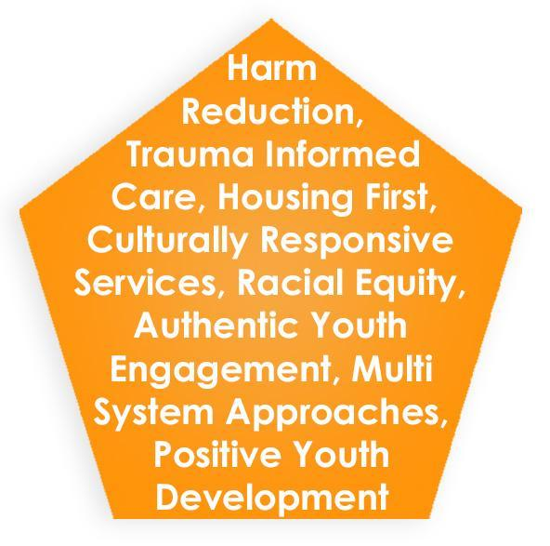
Additionally, there are eight evidence-based practices and valued principles that are central assumptions of the Plan, and all work emanating from the Plan is expected to incorporate them. They include:

  - Harm Reduction
  - Trauma-Informed Care
  - Positive Youth Development
  - Housing First
  - Culturally Responsive Services
  - Racial Equity
  - Authentic Youth Engagement
  - Multi-System Approaches

Harm Reduction: Harm Reduction is a philosophy and set of strategies aimed at reducing the negative consequences of harmful behaviors. It focuses on the prevention of harm, rather than the prevention of behaviors. Harm reduction strategies target individuals, environments, and policies in an effort to protect the health and safety of individuals and communities. The ideas of “meeting people where they are at,” celebrating any movement towards health and wellness, and ensuring that the client is in control of the direction and pace of change, are central to a harm reduction approach and have been indicated as a best-practice in working with young adults experiencing homelessness and housing instability.

Trauma Informed care and Positive Youth Development: Broadly speaking, trauma-informed care emphasizes creating individualized and tailored responses in settings and relationships in which a person can heal, and positive youth development emphasizes settings and relationships that support a young person’s ability to thrive.

Most unaccompanied youth experiencing homelessness have experienced significant trauma that may include exposure to multiple types of abuse, neglect, and violence. Additionally, the experience of homelessness in and of itself is often traumatic. SAMHSA defines programs and systems as “trauma-informed” when they meet the following criteria: “Realizes the widespread impact of trauma and understands potential paths for recovery; Recognizes the signs and symptoms of trauma in clients, families, staff, and others involved with the system; Responds by fully integrating knowledge about trauma into policies, procedures, and practices; and Seeks to actively resist re-traumatization." Trauma-informed approaches are fundamentally built on safety, connection, transparency, collaboration, choice, and empowerment. It is critical that all programs and strategies are trauma-informed in all aspects of how they approach and support young people to move towards improved stability, health, and well being.

Positive youth development (PYD) builds on the healing promoted through trauma-informed care by ensuring that YYA have opportunities to develop skills and talents through positive interactions with others, and by contributing to programs and projects. PYD recognizes, utilizes, and builds upon youths' strengths, and intentionally creates opportunities for mentoring, growth, and development. Many practitioners discuss the “5C’s” of PYD as creating “competence, connection, character, confidence, and caring” , These best practices should be integrated into all programs, systems, and policies designed to support YYA achieve better core outcomes (housing, education, employment, social and emotional well-being, etc). This Plan reinforces the need to tie these best practices together through strategic service delivery and housing models for youth experiencing homelessness.

MA Spotlight: Positive Youth Development- MA Department of Youth Services
“At DYS, we promote positive change among the youth we serve”
The Massachusetts Department of Youth Services (DYS) is a state agency that serves youth committed as juvenile delinquents or youthful offenders. DYS employs a continuum model of services and supervision guided by the tenets of Positive Youth Development (PYD) and the science of adolescent brain development.
DYS strives to promote positive change in the youth committed to state-care and custody by engaging in partnerships with communities, families, and government and provider agencies. By working in close collaboration with these entities, DYS continues to engage youth in rehabilitative services and help make communities better and safer places to live. DYS appreciates that positive change requires youth choice and has incorporated the value of youth and family input into decisions and case planning. The adoption of a PYD-focused approach to working with DYS involved youth ensures that youths’ strengths are identified and supported and that all youth are given opportunities to enrich their lives and become contributing members of their communities. By integrating PYD into its work, DYS is well positioned to support young people upon discharge and optimize their potential for success.

Housing First: HUD defines Housing First as: “ a proven approach in which people experiencing homelessness are offered permanent housing with few to no treatment preconditions, behavioral contingencies, or barriers. Supportive services are offered to maximize housing
stability and prevent returns to homelessness as opposed to addressing predetermined treatment goals
prior to permanent housing entry.” Additional services offered often include supports for substance use and mental health disorders, education and employment, primary health care, and community connections. However, as researcher Steven Gaetz has emphasized, a housing-first approach for youth and young adults may require slightly different approaches and accommodations than for older adults and must take into account the “developmental, social, and legal needs of young adults”,.

Spotlight: Housing First- Massachusetts Housing & Shelter Alliance
In 2013 the Massachusetts Housing & Shelter Alliance launched a new permanent supportive housing program for LGBTQ+ unaccompanied homeless young adults in partnership with AIDS Action Committee of Massachusetts, DIAL/SELF Youth & Community Services, and Justice Resource Institute. In addition to developmentally appropriate services tailored to the specific to the needs of LGBTQ young adults, the 32-unit pilot implemented the principles outlined in MHSA’s Home & Healthy for Good initiative, which has demonstrated that providing housing and supportive services to chronically homeless individuals through a low-threshold, Housing First model is less costly and more effective than managing their homelessness and health problems on the street or in shelter.

Culturally Responsive Services: It is essential when developing strategies to end and prevent youth homelessness that work is done to understand and apply the values, cultural and linguistic traditions, social and ethnic structures, as well as geo-political history of the community that is being served. According to the U.S. Department of Health and Human Services, Office of Public Health and Science (OPHS) Office of Minority Health, the standard for culturally responsive service is defined as “services that are respectful of and responsive to cultural and linguistic needs. Despite the misconceptions that culture refers only to knowledge, attitudes, beliefs, and behaviors influenced by race or ethnicity, the concept also includes factors such as age, gender, socioeconomic status, level of education, physical capacity, spirituality and religion, sexual orientation, and regional influences. This broader definition is important, as culturally displaced people may have specific barriers that impede their ability to access services in the same way as others. In addition to culturally responsive strategies and models, cultural responsiveness is also an essential component of data collection. Intentional use of culturally appropriate phrasing and approaches to data collection around particularly sensitive issues like race, gender identity, and sexuality plays a fundamental role in ethical data collection. All services and supports recommended in this Plan are expected to be culturally responsive.

Racial equity: Strategies to prevent and end youth homelessness must also address racial disparities and inequities. Racial inequities and disparities in the adult homelessness system are well documented, with 41% of people utilizing shelter systems identifying as African-Americanwhile making up only 13.3% of the general population. A 2011 study by George Carter from the Census Bureau found that even when controlling for poverty, African Americans were significantly more likely to become homeless than their white counterparts.

Young adults are impacted by many of the same forces that impact rates of homelessness among adults of color, including discrimination, education, employment, income disparities, and disproportionate incarceration rates. For example, the 2017 MA Youth Count reported that of the 501 young adults who met the Commission’s definition for homeless, 68% were youth of color. Nationally, the Voices of Youth Count study on youth homelessness reports that Hispanic, non-White youth had a 33% higher risk of reporting homelessness, and discusses this finding in their report: “Among racial and ethnic groups, African American youth were especially overrepresented, with an 83% increased risk of having experienced homelessness over youth of other races. Higher risk for African American youth experiencing homelessness compared to other races remained even when controlling for other factors like income and education.” This Plan recognizes the need to view all strategies for ending youth homelessness through the lens of racial equity.

Authentic Youth Engagement: This plan is grounded in the belief that the ideas and insights of YYA with lived experience should be at the front and center of any movement to end youth homelessness. Beyond simply sharing their experiences, YYA with lived experiences should be involved in information gathering, idea testing, and decision-making at local and state levels. The True Colors Foundation states that “authentic youth collaboration is about more than inviting a young person to share the stories of their past; it is also about providing the space for them to share their visions for the future.” Creating welcoming and accommodating spaces is not easy; the work of authentically involving YYA with lived experiences includes building trust, creating opportunities for meaningful engagement, investing in leadership development, addressing “adultism,” and the commitment to work through conflicts, and must be central to the work of ending youth homelessness in MA.
Spotlight: Authentic Youth Engagement - MA Department of Mental Health
The Department of Mental Health integrates youth and young adult voice into the work of the agency though the State Mental Health Planning Council subcommittees, Youth Development Committee (YDC) and the Statewide Young Adult Council (SYAC). The YDC was formed with young adults and providers in August 2001 to begin to address issues faced by youth aging out of the mental health system; and in 2007, SYAC was formed with only young adults to ensure that youth voice has a prominent role at DMH. Young adults with lived experience of mental health challenges and the mental health system chair both Committees; and they develop the agenda, topics for discussion, and goals and objectives of the Committees. Over the years, SYAC/YDC has added youth voice into various DMH and EOHHS initiatives, providing input on Department re-procurements, changing language on the Massachusetts Child & Adolescent Strengths and Needs (CANs) Assessment, and providing input into the Child Behavioral Health Initiative (CBHI) and Caring Together.

As a former SYAC co-chair said, “SYAC is a place where young adults with mental health issues can have their voice heard to other young adults, general populations, families, and the system. SYAC is a megaphone for young adults with mental health challenges.”

Multi-system approach: Many young adults experiencing housing instability and homelessness have had multiple interactions with other public systems before they experience homelessness. The education, child welfare, behavioral health, and criminal or juvenile justice systems are often connected with young people before they experience homelessness. However, most often these systems are not set up to identify risk for homelessness or communicate with one another, nor are they singularly equipped to address the multiple needs of young adults experiencing homelessness and housing instability. Identifying cross sections that make young people especially vulnerable or system involvement that puts YYA at a particular risk for homelessness is a core element of the Plan’s strategic process and is highlighted in the section on subpopulations. It is essential that these agencies and systems develop strategy at critical points of intersection to improve communication, share information, and develop a holistic multi-systems approach that is able to meet the needs that accompany overlapping and interdependent systems of discrimination or disadvantage that young people face in navigating these various agencies and services. Intentional, ongoing, and multi-system collaboration is needed to best serve young adults interacting with, transitioning from, and exiting these state systems, and an intersectional approach is a central component of the Plan.

5- NUMBERS & CHARACTERISTICS OF YYA EXPERIENCING HOMELESSNESS IN MA

“We’re youth – and that's not a good thing.
People assume that people our age don't usually go homeless.” -YYA, 19, Orleans
*
“My friends won't talk to me anymore. They think I have a disease.” - YYA, 20, Orleans

Every night there are hundreds of youth and young adults experiencing homelessness without a parent or guardian, and they may be found in in every community of Massachusetts. Over the course of a year that number is estimated to be over one thousand in Massachusetts, and according to recent data from Chapin Hall, across America that number may total upwards of 4.2 million youth and young adults who experienced a form of homelessness in the past 12 months.

The traditional method used to understand the prevalence of homelessness in the USA is the HUD-mandated Point-in-Time (PIT) counts. The PIT Count is conducted on a single night during the last ten days in January, and counts the number of sheltered and unsheltered homeless persons by household type and subpopulation. In recent years, HUD has expanded point-in time data collection to include information on the number of young adults and youth under 18 who are experiencing homelessness without a parent or guardian present. Nationally, the 2017 PIT counts reported that there were approximately 40,800 unaccompanied homeless youth nationally, roughly seven percent of the total homeless population and 11 percent of people experiencing homelessness as individuals. In Massachusetts, the 2017 PIT count reported 469 unaccompanied youth in Massachusetts, or 7.6% of people experiencing homelessness as individuals, and of these young people, 62 (13%) were unsheltered, and 57 individuals were under the age of 18.

In recognition that traditional counts, such as the HUD PIT count, often fail to identify and count hidden homeless populations such as youth, Massachusetts also conducts a separate statewide initiative to survey unaccompanied youth who are experiencing homelessness. In May 2017, the Massachusetts Special Commission on Unaccompanied Homeless Youth conducted the fourth annual Massachusetts Youth Count (“Count”), with participation from all 16 Continuums of Care. The 2017 Count included 2711 surveys from young people under the age of 24, and of these 501 met the Commission’s definition of homelessness and 314 met the HUD definition of homelessness (See Section 3“Definitions”). A large number of respondents (558) reported that they were not currently homeless but had been homeless in the past, and 50 responded that they were housed at the time of the survey but did not have a safe place to stay for next 14 days. (See Appendix G, 2017 Youth Count Report: Methodology and Findings).

It is important to remember that the HUD count and the MA Youth Count only represent the number of young people experiencing homelessness at a single point in time. When examining data that accounts for young people over the course of a year, that number doubles to over one thousand. The EOHHS funded demonstration projects reported that they received over 1200 unduplicated referrals to their programs, and ultimately were able to serve 799 unaccompanied youth.

Unaccompanied Homeless Youth:
Point-in time counts
HUD PIT, Jan 2017: 469
MA Youth Count, May 2017: 501
Annual count
Demonstration Projects FY17: 799 (20% LGBT)
DESE 2016-2017 school year: 1038
DTA 2017 (pregnant and parenting YYA only): 1368
Program level data, FY16: (1800 estimated)
Bridge Over Troubled Waters (Boston): 1500
DIAL-SELF (Greenfield): 202
LUK (Worcester): 114

Additionally, program-level numbers provide another data point helpful in determining baseline estimates of unaccompanied YYA experiencing homelessness in MA per year. The three MA programs receiving HHS Runaway and Homeless Youth funding report the following for FY17: Bridge Over Troubled Waters in Boston reports serving over 1,500 unaccompanied homeless youth; DIAL SELF in Greenfield served 202 individuals; and LUK in Worcester served 114 individuals. Just those three agencies served approximately 1,800 YYA in one year. There may be some duplication of the individuals using those programs; however, the programs are geographically distant from each other and the overlap, if present, can be assumed to be minimal.

While baseline counts provide a snapshot of the number of YYA struggling with homelessness and housing instability, they provide little information about the individuals represented. Examining the data from the MA Youth Count gives further insight. Of the 501 who met the Commission’s definition for homeless:

- 23% identified as LGBTQ+
- 68% were youth of color
- 50% became homeless before age 18
- 5.6% were currently under age 18
- 39% had ever been in placed in a group home or residential placement
- 26.4% had juvenile or criminal justice involvement
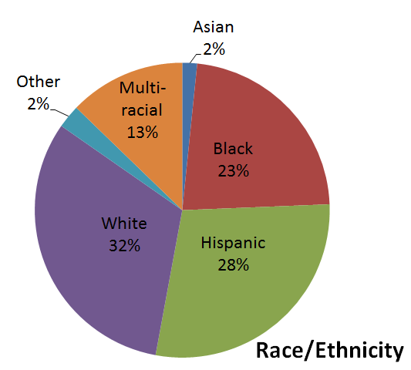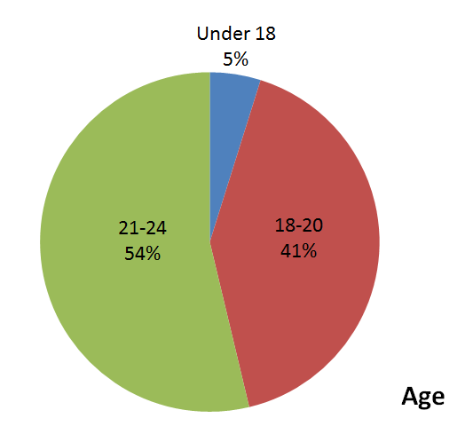

Data also tells us that youth experiencing homelessness are resilient, and many are accessing the education and employment services available to support them.

YYA homeless or at-risk from homelessness pursuing education and employment

WIOA-Youth: 307
In FY16 there were 307 (14%) of the 2195 young people served by WIOA-youth programs who identified themselves as homeless.

Demonstration. Projects: 667 (84% of total)
Enrolled in education or workforce training/development program

Dept. of Higher Ed: 1020
Students enrolled at public campuses in MA who were homeless or at risk of homelessness in 2016.

6. SUBPOPULATIONS

In addition to the general data on Massachusetts’ youth and young adults experiencing homelessness and housing instability, there are a number of subpopulations that have been identified locally and nationally and require special note. These subpopulations, many but not all of which are listed below, have additional characteristics and needs that require more tailored responses and approaches, and for some, being a part of the subpopulation itself puts the individual at a higher risk for experiencing homelessness. It is also important to note that many YYA have characteristics associated with multiple subpopulations, (i.e. an LGBTQ youth with a substance abuse disorder who is experiencing domestic violence). This requires holistic approaches to service delivery for YYA with multiple challenges.

Lesbian, Gay, Bisexual, Transgender, Questioning (LGBTQ) YYA:

“My family didn’t want me [because I am gay]. I’m too unique for them… ” - AC, 21, Boston

LGBTQ populations are overrepresented among youth experiencing homelessness. Nationally, while only 5% of youth overall identify as LGBTQ, an estimated 20- 40% of youth who are homeless identify as LGBTQ. Voices of Youth Count reported in Missed Opportunities: Youth Homelessness in America that LGBT youth had a 120% higher risk of reporting homelessness. In the 2017 MA Youth Count, 23% of respondents who met the Commission’s definition for homeless identified as LGBTQ. LGBTQ youth likely face these disparities in homelessness because they face high levels of rejection by families (including foster families), are more likely to become engaged in the juvenile justice system (due to factors such as acting out or defending themselves against violence or bullying), and are less likely to find culturally competent state or private services that can help them prevent homelessness, . Moreover, not only does this stigmatization and rejection lead to them to having higher levels of homeless, but it also exacerbates the severity of their conditions while experiencing homelessness, as young people who identify as LGBTQ are at elevated risk for violence, victimization, and exploitation while unstably housed. Within the LGBTQ population, transgender individuals are further marginalized and poorly served in mainstream services.

Best practices in working with the population include culturally responsive programming and services, providing education on current laws and the political climate; integrating inclusive measures such as gender inclusive bathrooms; and increasing representation and visibility (e.g., LGBTQ staff or board members; displaying rainbow images and safe space signage).

Victims of Sexual Trafficking and Exploitation:
“You have to experience things at this age that you just shouldn’t. You see people being raped, killed, and shot. It messes you up. – YYA, 18, Springfield
The Plan recognizes that sexual trafficking and the commercial sexual exploitation of children (CSEC) is a global problem that victimizes youth of all genders. CSEC occurs when individuals buy, trade, or sell sexual acts with a minor. The Victims of Trafficking and Violence Protection Act of 2000 defines sex trafficking as “the recruitment, harboring, transportation, provision, or obtaining of a person for the purposes of a commercial sex act .

A history of physical, emotional and sexual abuse is often common among victims. A study conducted by West Coast Children’s Clinic in 2012, found that 86% of exploited youth had involvement in child welfare and close to 80% had involvement with juvenile justice. In addition, a history of running away or current status as a runaway, and homelessness increases risk of commercial sexual exploitation. Sexual exploitation can increase the risk of homelessness; and homelessness increases the risk of sexual exploitation.

Youth who have experienced both homelessness and sexual exploitation may look similar to their non-exploited peers—they may be couch surfing, staying in shelters, or living outside. However, the majority of exploited youth—particularly girls and young women-- in the Commonwealth remain invisible. According to service providers, they are often under the control of exploiters and spend the majority of their time in hotels, motels, and apartments where they report exchanging sex with upwards of ten men per night. It is believed that the PIT and Youth Count miss these youth as they are not in shelters or the typical places that youth experiencing homelessness congregate.

There are currently no available baseline numbers for commercially sexually exploited youth and young adults in Massachusetts. Because these youth are so frequently invisible until they are encountered by law enforcement or other youth service providers, any count would be an undercount. However, the statistics from My Life My Choice, a Boston-based exploitation-focused service provider, offers a snapshot of these particularly vulnerable young people. In FY17, the program served 204 young people, and 85% were involved with DCF. Their average reported age of entry into the commercial sex industry was 14 years old.

Though not explicitly meeting the definition of sexual exploitation, it is important to note that the exchange of sex for survival needs (including food and shelter) is a common occurrence for YYA experiencing homelessness. The MA Youth Count found that 13.5% of youth experiencing homelessness reported having exchanged sex for money, housing or other needs, as compared to 2.2% of housed youth. Additionally, 25% of LGBT-identified youth reported having ever exchanged sex for money. These exchanges, while not technically exploitation, place youth at increased vulnerability for violence, victimization, and other negative health outcomes such as HIV, STIs, and unintended pregnancies. (See Appendix E: 2017 MA Youth Count Report and Findings)

There are a number of ways agencies and programs can be culturally responsive to sexual exploitation and vulnerability. They include training non-CSEC specific providers to identify, respond, and refer exploited youth to specialized programs, utilizing a trauma-informed approach, making sure that services are individualized, providing choices and options to the youth, conducting safety planning and harm reduction, connecting with culturally appropriate health care providers, and being consistent with services. In addition, collaborating with law enforcement and child welfare agencies are indicated as best practices.

Pregnant and parenting young adults:
“We’re expected to be on the same level with families who have already had housing history, education, and work experience. When in reality we have hardly any which makes us look less desirable to landlords, schools, and employers as were young and homeless. Older families get more favor as they’ve got more experience and ‘appear to have just fallen on bad times’ and us young parents ‘appear irresponsible’ along with naive.” - YYA, 22, Lawrence

Pregnant and parenting YYA experiencing homelessness have similar needs as other YYA populations as well as additional responsibilities related to providing care for their children. The nationwide 2017 Voices of the Youth Count found that parenting youth were three times more likely to experience homelessness than their non-parenting peers, and unmarried parenting youth had a 200% higher risk of reporting homelessness than their married peers. The MA Youth Count data shows that of the 501 youth who met the state definition of homelessness, 26% were pregnant or parenting. Sixty-six percent of these young people had custody of their children. As a point of comparison, only 3.6% of housed and never homeless youth and young adults were pregnant or parenting; and 76% of them have custody of their children. (See Appendix G, 2017 Youth Count Report: Methodology and Findings). Additionally, the Department of Transitional Assistance (which runs the state family shelter program) reported that as of the writing of this Plan they had 1,383 pregnant and parenting youth ages 14-24 considered homeless in their system.

Some of the essential and unique needs of this population include: accessible, adequate, and affordable child-care; direct housing support; education/employment and vocational support; navigation of health care appointments (for self and child); financial support with groceries/meals; transportation (including transportation for children to daycare); and laundry facilities. It is important to also consider the needs of parenting fathers in addition to parenting mothers. Mentoring by other parents, including fathers, who have experienced homelessness as young parents is highly recommended for this population, as well as providing parenting and life skills support that is tailored to young parents. Additionally, communication and collaboration across multiple systems is required to best serve this population.

Youth Under 18:
“For me, the first time I ran away from foster care was my ultimate scare factor. After that I was a little used to it – I knew what to do to get by. The first time I was so scared because I have nothing to eat, I only have three pairs of clothes, I don’t know where I am going to sleep, how I was going to take a shower, how I was going to be able to get to school, if I was even going to be able to go to school. A lot of that just was a bunch of things at once that scared the crap out of me – like, all of a sudden, this was really serious.” - YYA, 18, Framingham

Unaccompanied youth under the age of 18 face special challenges, ranging from individual developmental capacity to institutional, legal, and policy barriers to accessing services and supports. Many minors who find themselves disconnected from family structures and experiencing housing instability face the additional barrier of a lack of accessible, developmentally and age-appropriate resources, including safe transitions to the adult systems. The 2013 MA Unaccompanied Homeless Youth Commission Report explored ways that Mandatory Reporting laws might be creating an inadvertent barrier to services for unaccompanied minors. Many, though not all, of these minors experiencing homelessness are or were connected to the Department of Children and Families (DCF) or the Department of Elementary and Secondary Education (DESE). According to the 2017 Youth Count data, 51% of Massachusetts youth experiencing homelessness first became homeless before the age of 18. (See Appendix G, 2017 Youth Count Report: Methodology and Findings) Consequently, this population demands additional consideration, especially as a target for diversion, prevention, and intervention strategies.

Best practices in working with this population include: understanding and complying with mandated reporting laws, encouraging educational continuation, transition planning with DCF, assessing for sexual exploitation, embedding services in high schools, and providing flexible, low-threshold housing and programming options.

YYA with less than high school diploma or GED/HiSET:

“You can't get into college without good grades. You can't move forward without school. But how are you supposed to do your homework if you’re on the streets? And now, everything is online. Not everyone has access to a computer. And they say things like ‘it’s only $500 to get a computer.’
How am I supposed to get that?” - YYA, 19, Springfield

In Massachusetts, the 2017 Youth Count reported that 45% of YYA who met the Commission’s definition for homelessness were not in school nor had a diploma. (See Appendix E, 2017 Youth Count Report: Methodology and Findings). This data supports national data that indicates that YYA without a high-school diploma or high-school equivalency (HiSET/GED) are at a significant risk of homelessness. Voices of Youth Count revealed that young adults with less than a high school diploma or GED had a 346% higher risk of experiencing homelessness than their peers who completed high school and noted that “...of all of the indicators assessed, the lack of a high school diploma or General Equivalency Diploma (GED) was the most strongly correlated with higher risk of homelessness”.

Best practices in ensuring educational attainment for high school students includes addressing the stresses and instability of homelessness, integrating services into high schools and alternative education programs, dropout prevention and school reconnection services, and working across systems to ensure multiple needs are met.

MA Program Spotlight: Youth Harbors, a program of Justice Resource Institute, is embedded in high schools to serve homeless, unaccompanied students and YYA aged 18-22 in Massachusetts by connecting them with housing assistance, an adult support network, and individualized life skills development lessons so they can find safety in appropriate housing, graduate high school, and break the cycle of homelessness and poverty. The YouthHarbors program utilizes a wraparound model for service delivery that carefully crafts an individualized and flexible plan so as to meet the unique needs of each youth experiencing homelessness. Clients generally stay in the program for a total of 6 to 12 months, after which they are eligible for alumni services.

YYA with criminal justice involvement:
According to the 2017 Youth Count data, 29% of YYA experiencing homelessness had juvenile or criminal justice involvement. (See Appendix E, 2017 Youth Count Report: Methodology and Findings) It is important to note that some of the crimes committed may be directly related to the experience of homelessness; for example, trespassing, loitering, public urination, sitting or lying down in particular public places, shoplifting in order to obtain food, or engaging in physical altercations while on the streets. Additionally, young adults experiencing homelessness who also have criminal records or who have sexual offenses on their criminal record face additional barriers to exiting homelessness. The Center for Economic and Policy Research found that people who have been imprisoned are 30% less likely to find a job than their non-incarcerated counterparts. Such charges can impede individuals’ ability to receive housing vouchers, access employment, and ultimately obtain stability upon reentry into communities. These limitations then place individuals at a high risk for recidivism and provide an additional barrier to exiting homelessness. Attention must also be paid to communities that have jails and prisons. Youth and young adults may be released into homelessness and displaced from their community of origin after serving a sentence, which adds an additional population with specific needs to services and providers in that region. Youth and young adults displaced by incarceration experience barriers and limitations that may prevent them from effectively accessing services and regaining housing stability. Young adults with a history of incarceration may also have different and more specific needs than the general population of young people utilizing services in a given region.

Young adults involved with gangs are a population often overlooked in discussions on YYA homelessness, and it is important to note that not all gang-involved individuals have also been involved with the criminal justice system. There is very little information about the impact that gang involvement has on homelessness for young adults, though anecdotal evidence from violence prevention programming indicates that housing instability and homelessness is a salient issue for this population. YYA with a history of gang involvement may have changing or different housing needs based on whether they intend to exit a gang or access housing outside their community of origin. Recognizing the intersections that gang involvement has with criminal justice systems, violence, and trauma is a critical component to providing effective services and supports to this population.

Best practices to meet the needs of young adults with history of incarceration include cross-systems collaboration, developing prevention and diversion opportunities, including housing-related services, education and employment programs, gang-intervention, and alternatives to arrest. Additionally, in their policy brief “Youth Homelessness and Juvenile Justice: Opportunities for Collaboration and Impact” the Coalition for Juvenile Justice recommends improvement to re-entry planning by “including better transition planning for youth exiting the ... justice system, including housing, education, employment, and family-focused services (such as mediation or counseling to help youth reunify with their families in a safe and healthy way).”

Undocumented and Immigrant YYA:
Undocumented and immigrant YYA experiencing homelessness are often hidden from youth-serving agencies. Many of these youth have come to the United States for safety and/or economic opportunity. Some come with families, others arrived as unaccompanied minors. Their reluctance to engage with those perceived to be in positions of authority, fear of being deported, language barriers, and increase the risk for this population to remain hidden. Though statistics on the prevalence of this population are limited, the 2017 MA Youth Count identified that 15% of the YYA experiencing homelessness in Boston were born outside of the United States. Effective strategies for providing services to this population include providing services in native languages through bicultural staff; providing services in physical communities in which YYA reside/are from; and taking time to build trusting relationships.

YYA with Substance Use and/or Mental Health Disorders:
“You get stuck in your head, and then stuck in your life.” YYA, 22, Boston
*
“You emotionally can't go on. You wake up every morning not wanting to move. You have no motivation, so you stay in your bed all day. ... You just want to lay there and cry. And sometimes, you can't even cry. That’s how overwhelmed you are. Can't give yourself the basic needs you need when you’re so depressed. You just want to die all the time...” – YYA, 19, Springfield

In order to understand the lives of young people who use substances and experience homelessness, it is critical to explicitly make the connections between substance use, trauma, mental health, and homelessness.

Mental Health. The experience of homelessness is an additional stressor during a period of developmental changes that are inherently stressful. In addition to creating new experiences of trauma, the stress of experiencing homelessness can exacerbate pre-existing and underlying mental health conditions. In their 2014 briefing "Complex Trauma: Facts for Service Providers Working with Youth and Young Adults", The National Child Traumatic Stress Network describes YYA experiencing homelessness as a population that has "experienced early and multiple traumas;" describing that "these factors can lead to mental health challenges including depression, anxiety, PTSD, suicidal ideation, attachment issues, and substance use disorders." Some researchers have found rates as high as 80- 84% of homeless young adults in their studies meeting diagnostic criteria for a psychiatric disorder, . While many traumatic events occur before individuals leave home, YYA are likely to experience further violence, victimization, and trauma while on the street. This creates an environment where YYA are forced to attempt to address the trauma of their past while actively experiencing the trauma of their present circumstances.

The 2017 MA Youth count reported that 22% of youth experiencing homelessness in MA self-reported the need for mental health services. Barriers for YYA with mental health disorders include connection with and access to culturally responsive mental health services, difficulty accessing and storing medication, making and keeping appointments, and the pervasive stress of homelessness. A 24 year old participant in a focus group in Boston, described this as the “Catch-22 of homelessness” -- “If you can’t be stable, you can’t get stable.” Best practices for this subpopulation include trauma-informed services, accessible and culturally appropriate mental health services, and programs or service models that address multiple aspects of the individual, including complex mental and physical health issues, multiple stressors and risk factors, and competing priorities.

Substance Use: The National Healthcare for the Homeless Council reports that substance use rates among youth experiencing homelessness are consistently higher than their housed peers. Other research supports this statement, and a 2014 study of 601 homeless youth found that 60% of participants met DSM-IV-TR diagnostic criteria for a substance use disorder for at least one substance with 50% meeting DSM-IV-TR criteria for alcohol addiction, 60% for drug addiction, and 49% for substance dependence. The YYA participants from the focus groups conducted as part of this Plan often described substance use as a coping mechanism to deal with the stressors of homelessness.

Additionally, substance use among homeless youth often places them at risk for further negative health consequences. Studies have found that homeless youth using substances are more likely than their non-using peers to engage in sexual behaviors that put them at elevated risk for STIs and unintended pregnancies, such as unprotected sex, sex while under the influence of drugs or alcohol, and multiple partners, . Furthermore, program approaches to client substance use can inhibit relationship formation and continuation. A National Healthcare for the Homeless research review on “Behavioral Health among Youth Experiencing Homelessness” quotes Mary Howe, a service provider in San Francisco, as saying “I hear a lot of the youth we work with referred to as ‘hard to reach’ or ‘service resistant,’ and I can’t disagree more with those statements. They are on our streets and in our parks; they are in plain view. How much easier can they be to reach? They want services, but the truth is they want services that accept them the way they are, provide them with the things they need by people that treat them as individuals with respect and dignity.” Best practices in working with young adults using substances include harm reduction approaches, reducing stigma, providing access to culturally responsive treatment, understanding legal issues, an emphasis on engagement, multiple modalities of addressing substance use, and an integration of substance use services with other mental and physical health services.

Opioid Epidemic: The opioid epidemic was recently declared a national public health emergency. However, while opioid-related deaths are on the rise across the entire country, the opioid-related death rate in Massachusetts has far surpassed the national average, with an especially sharp rise in the last few years., While preliminary data in MA shows that the rate of opioid-related deaths in 2017 has decreased by 10% since 2016, nevertheless, opioid-related deaths in the Commonwealth were more than five times higher in 2016 than in 2000, with a 46% increase over 2014. According to the MA Department of Public Health’s (DPH) Chapter 55 report, approximately 4 percent of individuals age 11 or older have an opioid use disorder in Massachusetts and, in 2015, roughly two out of every three people who died from opioids were younger than 45. In the first half of 2017, 7% of all 15-24 year old deaths in MA were from opioid related fatal overdoses. Additionally, the MA Youth Count reported that 13.5% of YYA experiencing homelessness in the Commonwealth reported that one of the causes of their homelessness was parental substance use.

College students experiencing hunger and homelessness:
“A home would allow me the security to go to school without worrying about having my possessions being stolen or how I am going to get to class from wherever I spent the night." - YYA, 24, Boston

Among unaccompanied homeless youth in the Commonwealth, students who are enrolled in the state’s colleges and universities represent a population of unique interest and growing concern. Nationwide, a 2016 Wisconsin HOPE Lab survey of students at more than 70 campuses found that one in three community college students experienced hunger, half were housing insecure, and 14% were homeless. According to Voice of Youth Count national data, 29% of young adults who experienced homelessness were enrolled in college or another educational program at the time that they experienced homelessness. The MA Department of Higher Education reports 1,020 students on MA public campuses experiencing housing instability and food insecurity in 2016. These struggles often go unknown to faculty, administrators, and others who could be in a position to help.

Massachusetts is poised to become the first state in the U.S. to survey students across its public higher education system with the goal of identifying the specific nature and magnitude of the economic challenges facing students in a state that ranks high in housing costs and low in financial aid dollars awarded to those living in poverty. Anecdotal reports from the state’s public campuses indicate that a growing number of students are losing their housing due to rent increases and evictions, as well as disruptive family situations. Campus staff at twenty-four of Massachusetts’ 29 public campuses reported to the Department of Higher Education in 2016 that they were aware of homeless students who had matriculated and were attending classes while “couch surfing,” living in cars, or emergency shelters. One student who testified about his experiences before the Board of Higher Education told of living at Logan Airport for several months while attending classes at Bunker Hill Community College. Recently, the Department has learned of a group of students living in tents in the woods in Gardner, Massachusetts while attending Mount Wachusett Community College.
From a state policy standpoint, supporting homeless students already enrolled in higher education – even if the population is relatively small – makes sense because these individuals have overcome significant barriers to enroll and are already on a path to economic self-sufficiency – if they can succeed in obtaining postsecondary credentials. The Department of Higher Education is currently collaborating with staff from the Office of Health and Human Services to identify resources and create partnership models that might allow homeless students to find housing both on and off campus.

Domestic and Intimate Partner Violence:
Intimate partner violence (IPV) can be a contributing factor in homelessness, both in the impact of violence on the ability to sustain employment (and therefore housing) as well as the challenge of where a person can go to escape a violent partner. Agencies serving YYA experiencing homelessness may face particular challenges in serving YYA who are also experiencing domestic violence, including serving both partners, finding safe, confidential, and developmentally appropriate DV shelters, and the challenge of addressing the protective factors a violent partner may provide against other street violence. The Runaway and Homeless Youth and Relationship Violence Toolkit, suggests that best practices to create effective, meaningful, and appropriate services for YYA experiencing homelessness and intimate partner violence include: increasing youth provider awareness of approaches, responses, and resources for addressing IPV, and creating partnerships between IPV programs and service providers working with youth experiencing homelessness.

CONCLUSION
This plan was written with the urgency of knowing that many youth and young adults are currently experiencing homelessness and housing instability. We hope that the framing, data, recommendations, and action plan presented can serve as a deep and loud call to action so that every young adult in the Commonwealth can be housed, safe, supported, and able to fully use their strengths and talents.

Youth Advisory Board
By TC, 23, Boston

The YAB looks a lot like the 6:45 am sunrise
And feels a lot like knowing you’re not the only
Homeless youth in your city
It seems like it’s too early to be up and homeless
But the knowledge you have is the
Force that drives you forward.

That is the Youth Advisory Board to me –
The feeling that you can walk out of a homeless
shelter
AND homelessness all together
With your head held high and your
Chest pumped forward.

ACKNOWLEDGEMENTS

We would like to acknowledge the individuals and organizations that contributed to this plan, including EOHHS, the Plan’s Steering Committee, service providers, interviewees, the Liberty Mutual Foundation, and the Boston Church of the Advent for donating weekly meeting space. We would especially like to acknowledge and thank the young adults who shared their experiences, stories, insights, writing, and artwork. We are humbled by the trust you placed in us, and this Plan would not have been possible without you all.

EOHHS Partners  Iva Comey, Office of Children, Youth, and Families  Anny Domercant Office of Children, Youth, and Families  Linn Torto, MA Interagency Council on Housing and  Homelessness | CONSULTANTS  Jamila Bradley  Alice Colegrove, DrPH  Lauren Leonardis  Ayala Livny, M.Ed  Maxwell Nashashuk  Gabe Rosa
STEERING COMMITTEE  Amy Ackroyd, Children’s Friends and Family/ JRI  Michelle Botus, Department of Mental Health  Jeff Butts, Youth Harbors/ JRI  Gordon Calkins, Dept of Housing and Community Dev’p  Michael Collins, Community Teamwork Inc.  Joel Danforth, Department of Mental Health  Megan Donovan, AIDS Action Committee  Caitlin Golden, MA Housing and Shelter Alliance  Lisa Goldblatt-Grace, My Life My Choice  Lisa Goldsmith, DialSelf  Kevin Lilly, Samaritans Steps  Harry McCabe, Lynn Housing Authority  Amy Mullen, Department of Children and Families  Ita Mullarky, Department of Housing and Community Dev’p  Corey Prachniak-Rincón, MA LGBTQ Youth Commission  Carrie Richgels, AIDS Action Committee  Kelly Turley, Mass Coalition for the Homeless  Arlene Snyder, Bridge Over Troubled Waters  Kitty Zen, Unaccompanied Homeless Youth Commission | FOCUS GROUP HOSTS  Bridge Over Troubled Waters  Boston GLASS  Community Teamwork Inc.  DIAL SELF  Homelessness Prevention Council of  Orleans  Kilian’s House/ Catholic Social  Services  Lynn Housing Authority  SHINE/ Gandara Center  TEMPO/ Wayside Youth Services/ SMOC

APPENDIX A: FEDERAL DEFINITIONS OF HOMELESSNESS

The Department of Housing and Urban Development (HUD)
HUD defines homelessness as one of four categories. Category 3 is the only one that specifically mentions youth; however, youth are eligible and much more likely to qualify for assistance under the other categories.

HUD Categories of Homelessness:
Category 1 Literal Homelessness: Individuals and families who live in a place not meant for human habitation (including the streets or in their car), emergency shelter, transitional housing, and hotels paid for by a government or charitable organization.
Category 2 Imminent Risk of Homelessness: Individuals or families who will lose their primary nighttime residence within 14 days and has no other resources or support networks to obtain other permanent housing.
Category 3 Homeless Under Other Statutes: Unaccompanied youth under 25 years of age, or families with children and youth, who do not meet any of the other categories but are homeless under other federal statutes, have not had a lease and have moved 2 or more times in the past 60 days and are likely to remain unstable because of special needs or barriers.
Category 4 Fleeing Domestic Violence: Individuals or families who are fleeing or attempting to flee domestic violence, dating violence, sexual assault, or stalking and who lack resources and support networks to obtain other permanent housing. 2 Children and Youth and HUD’s Homeless Definition

Federal McKinney-Vento Act of 2009
“Unaccompanied” is defined under the Federal McKinney-Vento Act of 2009 as someone who currently lacks who a fixed, regular, and adequate nighttime residence, and/or (A) have experienced a long term period without living independently in permanent housing, (B) have experienced persistent instability as measured by frequent moves over such period, and (C) can be expected to continue in such status for an extended period of time because of chronic disabilities, chronic physical health or mental health conditions, substance addiction, histories of domestic violence or childhood abuse, the presence of a child or youth with a disability, or multiple barriers to employment.

U.S. Department of Health and Human Services (HHS):
A homeless individual is defined in section 330(h)(5)(A) as “an individual who lacks housing (without regard to whether the individual is a member of a family), including an individual whose primary residence during the night is a supervised public or private facility (e.g., shelters) that provides temporary living accommodations, and an individual who is a resident in transitional housing.” A homeless person is an individual without permanent housing who may live on the streets; stay in a shelter, mission, single room occupancy facilities, abandoned building or vehicle; or in any other unstable or non-permanent situation.
APPENDIX B -STAKEHOLDER INTERVIEW GUIDE

Questions for State Stakeholder Interviews

Definitions

- How does your agency define “homelessness” for a youth and/or Young adult?

- How do you know if there are youth or young adults experiencing homelessness within your system (DCF, EOLWD, etc…) (Is there a specific question your agency asks?)

Measurement Systems and Data

- Does your agency have a way to flag a YYA who is at-risk for becoming homeless?

- How/where do you collect data on housing status (homeless, at-risk, etc)

- Why might a young person experiencing homelessness NOT want to disclose their status to your agency? (maybe under 18? CORI? children?)

Communication and Collaboration

- When a YYA becomes homeless (or is identified) is there an internal conversation that occurs? If so, what does that look like?

- What other agencies are you talking to/collaborating with (formally and informally) in regards to YYA homelessness?

- What and/or Who helps these inter-agency conversations? What partners could better facilitate these conversations, and more specifically, who has the role/resources/and responsibility to facilitate these conversations?

- What might such a protocol for interagency collaboration look like, so it’s not a one-off process? What has worked in the past and how might it be improved/enhanced ?

- What gets in the way of inter-agency collaboration?

- How might the needs of YYA experiencing homelessness in YOUR system be different from YYA exp homelessness in other systems?

- When a young person is about to be discharged from your agency, how might transition planning be enhanced to prevent homelessness?

- Tell me more about how your agency handles crisis-response and intervention vs long-term-solutions for stability of a young person experiencing homelessness.

Backbone support
- What funding streams support your agency’s work with young people experiencing homelessness?

- Is the issue of YYA homelessness something that everyone is your agency is sensitive and equipped to work with? or it is outsourced/ a pet project of someone?

- What does your agency need in order to better support YYA experiencing homelessness? (resources? Training? Forums for collaboration?)

- How has state-level policy impacted your work at ___ (agency). Are there other policies that would be helpful?

- How can you envision this State Plan supporting a regional approach to ending youth homelessness?

- Are you familiar with the Demonstration Projects? If so, how have they impacted your work and outlook on this issue?

- MA does not currently have a central/ state-level office or position focusing solely on youth homelessness issues. If this were created, how might a central State office/leadership position better support your work? What sort of responsibilities would you want to see in the job description?

Direct Support to YYA

21) What are some of the supports and services your agency offers YYA who are experiencing homelessness?

22) What does YYA involvement/leadership development look like within your agency? What might better support your work around this?

23) Are there ways that programs funded by your agency intentionally connect and support YYA to discover and develop their talents and strengths?

Final question:
24) what do you think should be done to better support YYA who experience homelessness in MA?

APPENDIX C. FOCUS GROUP GUIDE

YYA Focus Groups -MA STATE PLAN TO END YOUTH HOMELESSNESS

I. Introduction –
● Individual introductions
● Group agreements
● Definitions

II. Supports/ Barriers
We want to start by looking at Barriers – What gets in the way of you getting your needs met? (Needs such as education, employment, income, housing, mental and physical health, and support). The way we are going to do this is as a game.

Instructions:
1) Divide into 2 or 3 groups (try to have no more than 3 people per group) – count off by 2s or 3s or just divide by location in the room.

Once group is divided:
2) Each group is going to get a pad with the letters A – Z written on it
3) Each group gets a marker for each person in the group (2 or 3 markers per group)
4) We are going to give you all 3 minutes to come up with a list of things that get in the way of getting your needs met. You can write down one word for each letter. After the 3 minutes is up, we will compare your lists.
5) HOWEVER, your team will only get points for unique words – words that the other teams haven’t also come up with.

DISCUSSION:
● At each word identified, ask why or how it's a barrier – what does it get in the way of doing? (Limit time to one minute- Facilitator gets to judge if team gets a point or not).
● After all of the words are discussed, ask – “are any additional barriers that we / the state should know about?”

III. Systems
● The purpose of this first activity is to get information directly from you about barriers, gaps, best practices, and opportunities to improve the systems that affect YYA experiencing homelessness

What are the systems you interact/have interacted with?

Activity:
● Large post-it papers around the room with various systems
● Each person gets a post-it pad (all the same color), puts the post-it on a page if has had interaction (doesn’t have to be good interaction) with that system

Three rounds:
● Round one (YELLOW post-it) “What systems were you connected with before you became unstably housed (if more than one time with the same system, add a “x2” etc to it)

● Round Two (PINK post it) “What systems were you connected with while experiencing homelessness?” ,
● Round three (BLUE post it) “who did you tell / who knew you were homeless”
o Systems to include:
● DYS /juvenile justice
● Criminal justice / legal system / adult corrections system
● DCF/ Foster Care/ CHINS
● High School
● GED prep classes/ HiSET
● VoTech or other Employment program such as Job Corps
● Individual therapist
● Department of Mental Health
● DTA/ public benefits: food stamps, WIC
● DDS: SSI/SSDI
● Health Care/ Doctor
● Housing Authority
● Higher Ed (colleges)
● Substance Use treatment
● Social services (general)
● LGBTQ support service
● Other (write-in on the post it note)

Discussion:
● What do you notice? Does it seem like there are any trends or similarities?
o Probe: is there anything to note about systems or people were connected with (pink note) but didn’t tell (blue note)

We are going to shift to asking some more personal questions about your experiences, and if you are comfortable, we would like you to speak specifically about your experiences rather than more generally about other people’s experiences.

1) At what point did you realize that you were going to be “capital H -homeless”? (what was happening? At what point in your life?)
o Probe: Looking back, was there a time that you were actually homeless but didn’t think that you were?

2) When you first found yourself without a stable place to stay, was anyone or any organization or any system helpful?
● Is there anyone/ any organization that could have helped you that didn’t?

3) At what point did you realize that you HAD to tell someone?
o Was there anyone you intentionally did NOT tell? Why?
o What made it difficult to tell people?

4) How did you find resources, programs, or supports (internet, social network?) ?
● If you looked on the internet, what did you google?

Next we are going to ask some questions that will ask you to reflect a bit on your experiences…

5) Looking back, is there anything that you wish had been done by a provider when you first found yourself in the situation?

6) What advice would you give yourself or other people in this situation?

IV. Summary questions: A few last questions…
1) Do you think there is anything that is different about being young and unstable HERE than in other places in the state? What/ why? (note if compare to other states…)

2) Are there ways that you feel your sexual orientation or gender identity have impacted your experience with homelessness or housing instability? (only if it seems to pertain and feels safe)

3) Are there ways that you feel your racial or ethnic identity have impacted your experience with homelessness or housing instability?

4) In summary, we are trying to write a Plan for the State to better support and eventually end youth homelessness . What do you wish people knew about what it's like to be young and unstably housed? Think about service providers, policy makers, the general public…
o Go around room, each person can say one or two things
o what do providers not realize about what it’s like to be young and unstably housed?
o What do you think would surprise most people?

5) If we could magically get the State to do one or two things to better support and/or end YYA homelessness, what would you recommend? Or, what would you change if you had the power to change things?

V. Photovoice Project introduction

VI. Conclusion and Evaluation

Plus/ Delta Evaluation

APPENDIX D: STATEWIDE PROVIDER SURVEY

State Plan to End Youth Homelessness- Provider survey
Survey Goal:
In creating the MA State Plan to End Youth and Young Adult (YYA) Homelessness, we have been collecting information from many sources including focus groups with YYA who have experienced homelessness and interviews with State agencies and leaders. Direct service staff have unique perspectives on the challenges faced by individuals AND organizations, and can lend another layer of depth to our understanding of the work needed to be done in the Commonwealth to ensure that homelessness for youth and young adults is rare, brief, and/or a one-time occurrence. With this in mind, we invite you to contribute your feedback and insight to ensure the State Plan to End YYA Homelessness reflects your experiences.
If you have any questions, comments, or want to be further involved in the State Plan, please contact Ayala Livny at ayala.livny.consulting@gmail.com
Questions: A. DEMOGRAPHICS:
1)Was your agency or program a participant in the FY17 State-funded demonstration projects?
- yes
- no
- Don’t know
1A)If yes, which consortium/region was your agency a part of?
- Merrimack Valley/ CTI
- Metro Boston/United Way of Massachusetts Bay
- Fall River/ Catholic Social Services
- Franklin, Hampshire, Berkshire Counties / Community Action
- North Shore / Lynn Housing and Neighborhood Development
- Worcester/ Central Mass Housing Alliance
- Hampden County - City of Springfield
- Metro West - SMOC (Framingham)
2) What CoC are you a part of?
- Attleboro/Taunton/Bristol County
- Balance of State
- Boston
- Cambridge
- Cape Cod/Islands
- Fall River
- Gloucester/Haverhill/Salem/Essex (North Shore)
- Lowell
- Lynn
- New Bedford
- Pittsfield/Northampton/Berkshire/Franklin/Hampshire Counties
- Quincy/Brockton/Weymouth/Plymouth City and County CoC
- Somerville
- Springfield/Holyoke/Chicopee/Westfield/Hampden County
- Worcester City and County
- I DON’T KNOW WHAT CoC WE ARE A PART OF
B. Outreach:
Some YYA Focus Group participants identified that there was a significant gap of time between their first experience of homelessness and connecting with a service organization. They also identified that this gap of time was when they were most vulnerable to violence and exploitation.
3) How do you currently identify or reach out to potential clients?
- Street Outreach
- Referrals (if yes, from whom_____________________________)
- Peer Outreach (formal)
- Peer Outreach (informal/ word of mouth)
- Collaborations
- Advertisements
- On-line/ Internet outreach (if yes, what sites/forums ___________________)
- Other
4) What makes it difficult for you to connect with potential clients that would benefit from your programs?

C. Resources
YYA focus group participants also identified not knowing the resources available to them, even if they are connected to a service program.
5) Is there a resource guide SPECIFICALLY for services available for YYA experiencing homelessness in your community?
- Yes, paper
- Yes, online
- There is a resource guide, but it's not specific for youth/ young adults
- No
5A) *If yes, which agency created the guide(s)? ______________
5B) If there is a guide, is it something that you use?
- Frequently
- Rarely
- Never , please explain why _______________________________________________
6) What would make it easier for YOU to know about and connect with other services available to your clients?

7)What additional types of services/programs/resources are most needed in your community to prevent and end YYA Homelessness? Please rank in order of importance to you. We assume that all of the items below would be culturally competent, trauma-informed, and developmentally appropriate.
- Emergency shelter
- Transitional housing
- Permanent Supported Housing
- Employment services
- General Case Managment
- Mental Health Services
- Substance Use Disorder Services
- Physical health / medical services
- LGBTQ+ supports
- Education support and services
- Recreational activities
- Life skills support
- Other ___________________

D. Flexible funding
Many programs have access to flexible funding to meet a variety of needs of their clients. We know that some flexible funding dollars are now decreasing, and we are trying to learn more about how important they have been.

8)Has your program had access to flexible funds?
- Yes
- No

9) If you have had access to flexible funds, what have you used them for?
- Housing/rent costs: if yes, please describe_______________
- Transportation
- Child Care
- Legal fees
- Work-related needs
- Education-related needs
- IDs
- Other ________________________________

10) Could you share one short story of the flexible funding meeting a significant unmet need?

E. Staff Connection
11) How connected do you feel to other providers IN YOUR COMMUNITY doing similar work?
- Not at all
- Occasionally connected
- Connected
- Very Connected

12) How connected do you feel to other providers OUTSIDE OF YOUR COMMUNITY doing similar work?
- Not at all
- Occasionally connected
- Connected
- Very Connected

13) What might you gain from a better connection to providers outside your community doing similar work?

14) Can you share an example of a time that you being connected (or disconnected) from other services has impacted your ability to serve your clients?

15) How connected do you feel to your local CoC?
- Not at all
- Occasionally connected
- Connected
- Very connected

15b) (if applicable) Can you share an example of how you have benefitted from a connection to your local CoC?

F. Other Comments
16) Is there anything else you think we should know as we are making recommendations for how the State of MA can make YYA Homelessness rare, brief, and a one-time occurrence?

APPENDIX E: 2017 Youth Count Report: Methodology and Findings

Facing Massachusetts' Housing Crisis: Special Senate Committee on Housing Report 2016 Mar
The Lesbian, Gay, Bisexual, and Transgender (LGBT) Homeless Youth Provider Survey
A Continuum of Care (CoC) is a regional or local planning body that coordinates housing and services funding for families and individuals.
https://www.usich.gov/resources/uploads/asset_library/Youth_Criteria_Benchmarks_FINAL.pdf
https://www.usich.gov/resources/uploads/asset_library/Youth_Criteria_Benchmarks_FINAL.pdf
https://workspaceonhomelessness.ca/youthhomelessness/discussion/community_planning/yap_canadas_first_tool_for_assessing_youths_risk_of_homelessness_and
https://www.ysnmn.org/#/home
The Executive Office of Labor and Workforce Development’s Department of Career Services provides oversight of the federally funded Workforce Innovation and Opportunity Act (WIOA) Youth Program. WIOA-youth allocates funds to Workforce Boards in 16 areas throughout Massachusetts to procure services designed to help in-school and out-of-school youth complete their secondary education, enter into postsecondary education/training, or enter into employment.
Single Points of Contact (SPOCs) are designated safe and supportive college administrators who are committed to helping unaccompanied homeless youth successfully navigate the college-going process. SPOCs implement a streamlined process on their campuses to help young adults successfully matriculate into higher education and address barriers to enhance academic advancement. SPOCS also can help address multiple barriers including the waiving of application and other fees at higher education institutions (when possible), changing the timing of housing deposits so that students can pay when financial aid is received by the student, and connecting students with other community and higher education resources such as financial literacy, peer support groups, food banks, etc.
From the Boston PIC: (http://bostonpic.org/) “The Boston Private Industry Council is both the city’s Workforce Development Board and its school-to-career intermediary organization. The PIC brings together employers, educators, and workforce organizations, often by industry sector, to help guide the agenda for education and workforce preparation. ” The workforce boards are funded through the MA Executive Office of Labor and Workforce Development.
https://www.hudexchange.info/resources/documents/Guide-for-Engaging-Youth-in-Decision-Making-and-Planning.pdf
The mental and physical health of homeless youth: a literature review. Edidin JP1, Ganim Z, Hunter SJ, Karnik NS., Child Psychiatry Hum Dev. 2012 Jun;43(3):354-75. doi: 10.1007/s10578-011-0270-1.
https://youth.gov/youth-topics/runaway-and-homeless-youth/federal-definitions
The Commonwealth of Massachusetts Special Commission on Unaccompanied Youth: Report to the Great and General Court, Executive Office of the Governor, and Office of the Child Advocate, 2013.
Category 3 is the only one that specifically mentions youth; however, youth are eligible and much more likely to qualify for assistance under the other categories.
https://www.hudexchange.info/resources/documents/HUDs-Homeless-Definition-as-it-Relates-to-Children-and-Youth.pdf
https://www.usich.gov/resources/uploads/asset_library/Youth_Criteria_Benchmarks_FINAL.pdf
An Act Promoting Housing And Support Services To Unaccompanied Homeless Youths
The General Appropriations Act language (4000-0300) states: “ $150,000 shall be expended for the work of the Massachusetts unaccompanied homeless youth commission to determine the scope of need among unaccompanied youth and young adults ages 24 and younger who are experiencing homelessness, and to identify and implement potential models for appropriate service delivery to unaccompanied homeless youth in urban, suburban, and rural areas of the commonwealth; and provided further, that not later than January 18, 2016, the executive office of health and human services shall submit a report to the house and senate committees on ways and means detailing the methodology used to project caseload and utilization in fiscal year 2015 and fiscal year 2016
A Continuum of Care (CoC) is a regional or local planning body that coordinates housing and services funding for families and individuals.
(Line Item 4000-0007; MA General Law Chapter 6A, Sections 16W and 16X)
https://www.usich.gov/tools-for-action/framework-for-ending-youth-homelessness
http://harmreduction.org/about-us/principles-of-harm-reduction/
https://www.usich.gov/resources/uploads/asset_library/PYIM_1.pdf
https://www.samhsa.gov/nctic/trauma-interventions
Kinniburgh, K. & Blaustein, M. (2005). Attachment, Self-Regulation, and Competency: A comprehensive framework for intervention with complexly traumatized youth. A Treatment manual. Boston
Pittman, K., Irby, M., Tolman, J., Yohalem, N., & Ferber, T. (2003). Preventing Problems, Promoting Development, Encouraging Engagement: Competing Priorities or Inseparable Goals?. Based upon Pittman, K. & Irby, M. (1996). Preventing Problems or Promoting Development? Washington, DC: The Forum for Youth Investment, Impact Strategies, Inc. Available online at www.forumfyi.org.
http://dhhs.ne.gov/publichealth/MCAH/Documents/HYN2015-FiveCs_YouthDevelopment.pdf
https://www.hudexchange.info/resources/documents/Housing-First-Permanent-Supportive-Housing-Brief.pdf
Gaetz, Stephen. (2014). A Safe and Decent Place to Live: Towards a Housing First Framework for Youth. Toronto: Canadian Observatory on Homelessness Press.
Schneir, A., MPH, Casey, E., LCSW, & Krummes, E., LCSW. (2016). Creating Trauma-Informed Coordinated Entry Systems for Youth (Issue brief). Hollywood Homeless Youth Partnership. http://hhyp.org/wp-content/uploads/2013/04/Creating-Trauma-Informed-CES-for-Youth.Final_.pdf
The National CLAS Standards
Addressing Cultural and Linguistic Competence In the HCH Setting: A Brief Guide
https://www.hudexchange.info/resources/documents/2017-AHAR-Part-1.pdf
https://www.census.gov/quickfacts/fact/table/US/PST045216
Carter, G. R., III. (2011). From Exclusion to Destitution: Race, Affordable Housing, and Homelessness. Cityscape: A Journal of Policy Development and Research , 13(1), 33-70. Retrieved from http://www.thecyberhood.net/documents/papers/cityscape.pdf http://www.thecyberhood.net/documents/papers/cityscape.pdf
http://us.thinkt3.com/blog/racism-and-youth-homelessness
Morton, M.H., Dworsky, A., & Samuels, G.M. (2017). Missed opportunities: Youth homelessness in America. National estimates. Chicago, IL: Chapin Hall at the University of Chicago.
https://network.truecolorsfund.org/youth-collaboration-toolkit/
Morton, M.H., Dworsky, A., & Samuels, G.M. (2017). Missed opportunities: Youth homelessness in America. National estimates. Chicago, IL: Chapin Hall at the University of Chicago.
https://www.hudexchange.info/resources/documents/2017-AHAR-Part-1.pdf
https://www.hudexchange.info/resource/reportmanagement/published/CoC_PopSub_State_MA_2017.pdf
Durso, L.E., & Gates, G.J. (2012). Serving Our Youth: Findings from a National Survey of Service Providers Working with Lesbian, Gay, Bisexual, and Transgender Youth who are Homeless or At Risk of Becoming Homeless. Los Angeles: The Williams Institute with True Colors Fund and The Palette Fund.
Morton, M.H., Dworsky, A., & Samuels, G.M. (2017). Missed opportunities: Youth homelessness in America. National estimates. Chicago, IL: Chapin Hall at the University of Chicago.
Keuroghlian A, Shtasel D, Bassuk E. Out on the street: A public health and policy agenda for lesbian, gay, bisexual, and transgender youth who are homeless. American Journal Of Orthopsychiatry [serial online]. 2014; 84(1):66-72. Available from: PsycARTICLES, Ipswich, MA. Accessed December 4, 2017.
Ray, N. (2006). Lesbian, gay, bisexual and transgender youth: An epidemic of homelessness. New York: National Gay and Lesbian Task Force Policy Institute and the National Coalition for the Homeless.
Victims of Trafficking and Violence Protection Act of 2000 (22 USC 7102)
WestCoast Children’s Clinic (2012). Research to Action: Sexually Exploited Minors (SEM) Needs and Strengths. Oakland, CA: WestCoast Children’s Clinic)
http://www.fightingexploitation.org/
Morton, M.H., Dworsky, A., & Samuels, G.M. (2017). Missed opportunities: Youth homelessness in America. National estimates. Chicago, IL: Chapin Hall at the University of Chicago.
Morton, M.H., Dworsky, A., & Samuels, G.M. (2017). Missed opportunities: Youth homelessness in America. National estimates. Chicago, IL: Chapin Hall at the University of Chicago.
L. P. (2016, June). Youth Homelessness and Juvenile Justice: Opportunities for Collaboration and Impact (Issue brief No. 1). http://juvjustice.org/sites/default/files/resource-files/policy%20brief_FINAL.compressed.pdf
Bucknor , C., & Barber*, A. (2016, June). The Price We Pay: Economic Costs of Barriers to Employment for Former Prisoners and People Convicted of Felonies(Rep.). Retrieved http://cepr.net/images/stories/reports/employment-prisoners-felonies-2016-06.pdf
L. P. (2016, June). Youth Homelessness and Juvenile Justice: Opportunities for Collaboration and Impact (Issue brief No. 1). http://juvjustice.org/sites/default/files/resource-files/policy%20brief_FINAL.compressed.pdf
National Child Traumatic Stress Network. (2014). Complex trauma: Facts for service providers working with homeless youth and young adults. Los Angeles, CA, & Durham, NC: National Center for Child Traumatic Stress.
Castro AL, Gustafson EL, Ford AE, Edidin JP, et al. Psychiatric disorders, high-risk behavior, and chronicity of episodes among predominantly African American homeless Chicago Youth. JHCPU. 2014; 25(3):1201-1216.
Quimby EG, Edidin JP, Ganim Z, Gustafson E, Hunter SJ, Karnik NS. Psychiatric disorders and substance use in homeless youth: A preliminary comparison of San Francisco and Chicago. Behav Sci. 2012; 2:186-194.
Behavioral Health among Youth Experiencing Homelessness (4th ed., Vol. 3, Issue brief). (2015). National Health Care for the Homeless Council . doi:https://www.nhchc.org/wp-content/uploads/2011/09/in-focus-behavioral-health-among-youth.pdf
Bender K, Thompson S, Ferguson K, Langenderfer L. Substance use predictors of victimization profiles among homeless youth: a latent class analysis. J Adolesc. 2014; 37:155-164.
Kennedy DP, Tucker JS, Green HD, Golinelli D, Ewing B. Unprotected sex of homeless youth: results from a multilevel analysis of individual, social network, and relationship factors. AIDS Behav. 2012; 16(7):2015-2032.
Tucker JS, Ryan GW, Golinelli D, et al. Substance use and other risk factors for unprotected sex: results from an event-based study of homeless youth. AIDS Behav. 2012; 16(6):1699-1707.
National Health Care for the Homeless Council. (September 2016). Substance Abuse Among Youth Experiencing Homelessness. Healing Hands, 20:2. (Author: Melissa Jean, Writer). Nashville, TN: Available at: www. nhchc.org
https://www.whitehouse.gov/the-press-office/2017/10/26/president-donald-j-trump-taking-action-drug-addiction-and-opioid-crisis
https://www.mass.gov/files/documents/2017/11/15/2017-annual-update-action-items-gov-working-group.pdf
https://www.mass.gov/files/documents/2017/08/31/data-brief-overdose-deaths-aug-2017.pdf
http://www.mass.gov/chapter55/
https://www.mass.gov/files/documents/2017/08/31/opioid-demographic-aug-2017.pdf
Goldrick-Rab, S., Richardson, J., & Hernandez, A. (2017). Hungry and Homeless In College: Results from a National Study of Basic Needs Insecurity In Higher Education (Rep.). Wisconsin HOPE Lab. doi:http://wihopelab.com/publications/Hungry-and-Homeless-in-College-Report.pdf
Morton, M.H., Dworsky, A., & Samuels, G.M. (2017). Missed opportunities: Youth homelessness in America. National estimates. Chicago, IL: Chapin Hall at the University of Chicago.
Runaway & Homeless Youth And Relationship Violence Toolkit. (n.d.). https://www.nrcdv.org/rhydvtoolkit/index.html
According to the authors: “This Toolkit was developed by and for advocates in the runaway and homeless youth (RHY) and domestic and sexual assault (DV/SA) fields to help programs better address relationship violence with runaway and homeless youth. The Toolkit organizes information, resources, tips and tools drawn from the wealth of information gathered when the two service systems were convened through local collaborative projects funded by the Family and Youth Services Bureau (FYSB) of the U.S. Department of Health and Human Services.”
https://www.hudexchange.info/resources/documents/HUDs-Homeless-Definition-as-it-Relates-to-Children-and-Youth.pdf
https://www.hudexchange.info/resources/documents/HomelessAssistanceActAmendedbyHEARTH.pdf
Section 330 of the Public Health Service Act (42 U.S.C., 254b)

